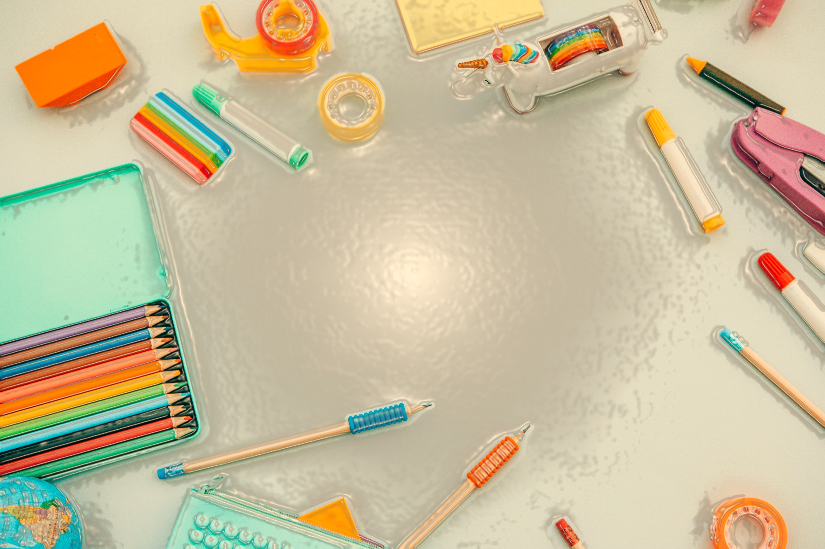

UNIT:

Living in the wider world

Climate change and sustainability

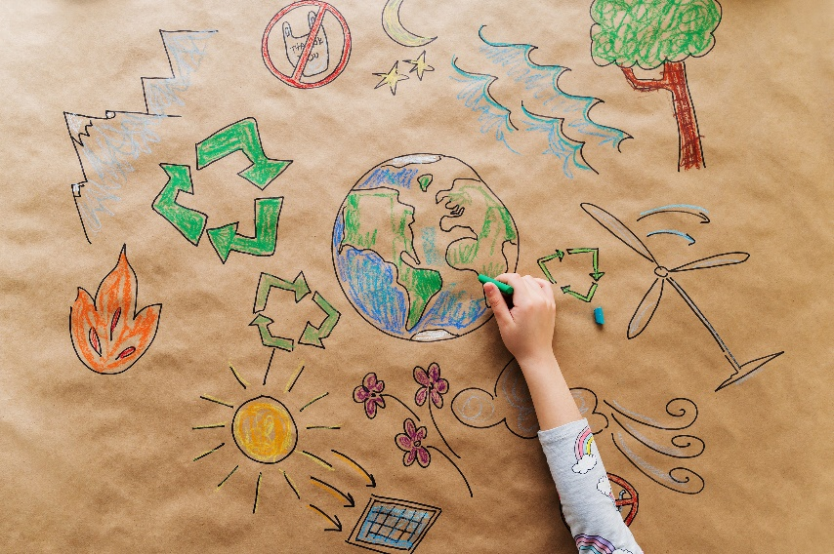

Name:

School:

Term:

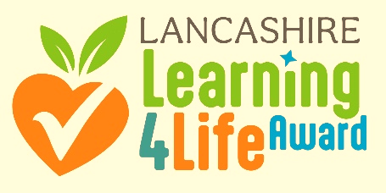


Remember: Before you start any lessons, remind yourselves of your class group agreements for PSHE learning!

How confident are you with sustainability and climate change?
1 | 2 | 3 | 4 | 5 | 6 | 7 | 8 | 9 | 10

OVERVIEW

This unit is all about climate change and sustainability. We will be learning all about some simple changes that you can make to live more sustainably and have a positive impact on climate change and your world in the future.
Key vocabulary you may learn:

Sustainability | The quality of not being harmful to the environment or depleting natural resources, and thereby supporting long-term ecological balance.
Climate change
Pollution
Diet
Active travel
CO2 (Carbon Dioxide)
What do you already know about sustainability and climate change?

Sustainability and climate change
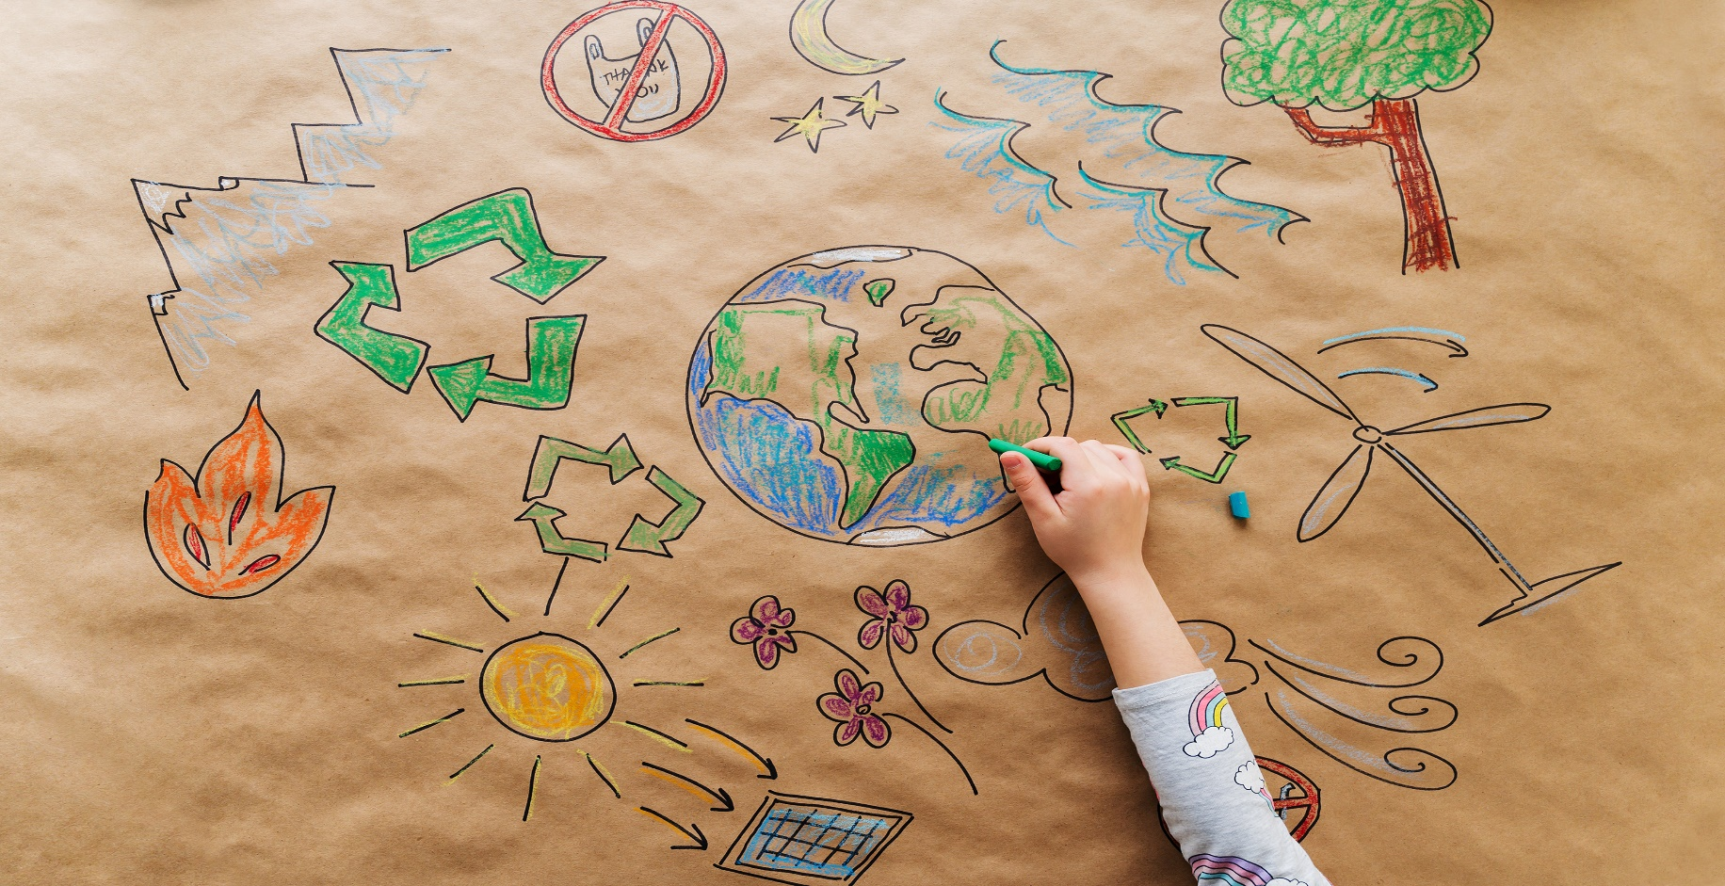

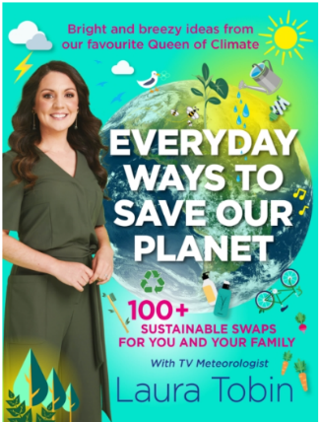
Session 1

Pollution

'No one can do everything but everyone can do something' (Laura Tobin, 2022)

In this first session, you have been thinking about the best way to impact the environment and found out some facts about plastic pollution.
You have also be learning about the waste hierarchy pyramid and the vocabulary associatated with this.

Now is the time to reflect on your learning from the session.
Think about:
My 'pollution pledge' is:

One thing I would like to find out more about is:

One thing I know now that I didn't know before is:

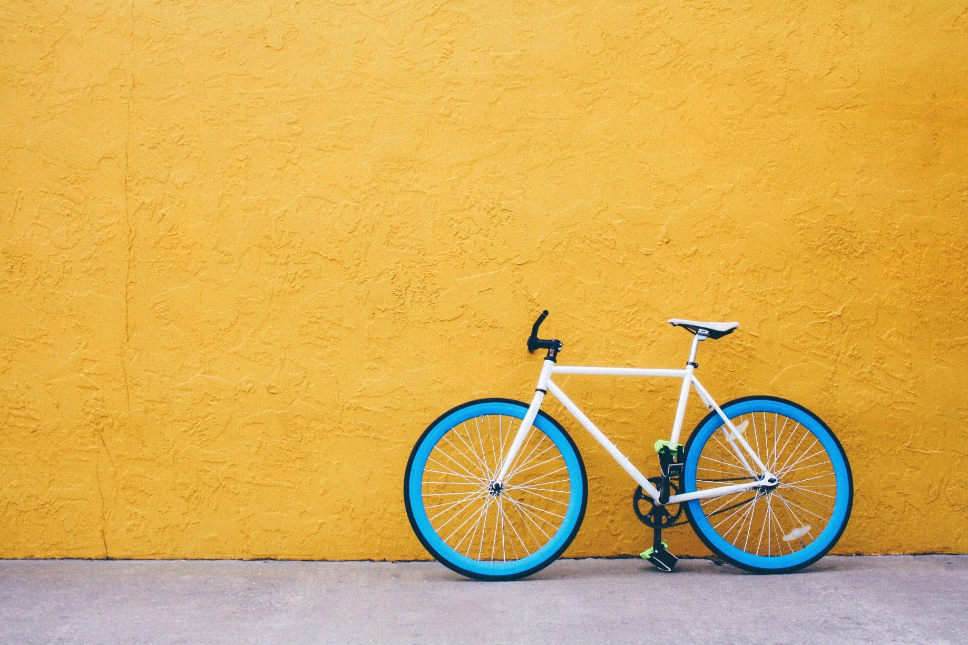
sESSION 2

ACTIVE TRAVEL

How do you travel to school? ___________________________________________________

How many miles is this? ___________________________________________________

How many km is this? ___________________________________________________

How would you like to travel to school? ________________________________________

If you are unable to change how you travel, what changes could you make to current journey to make it more active?
_____________________________________________________________________________________________________________________________________________________________________________________________________________________________________________________________
Draw out your obstacle course and label it with the correct activities/equipment:

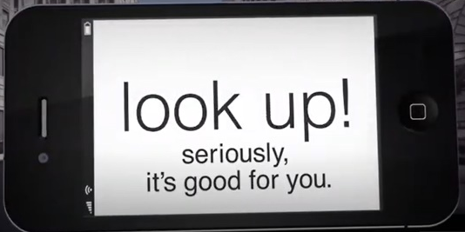

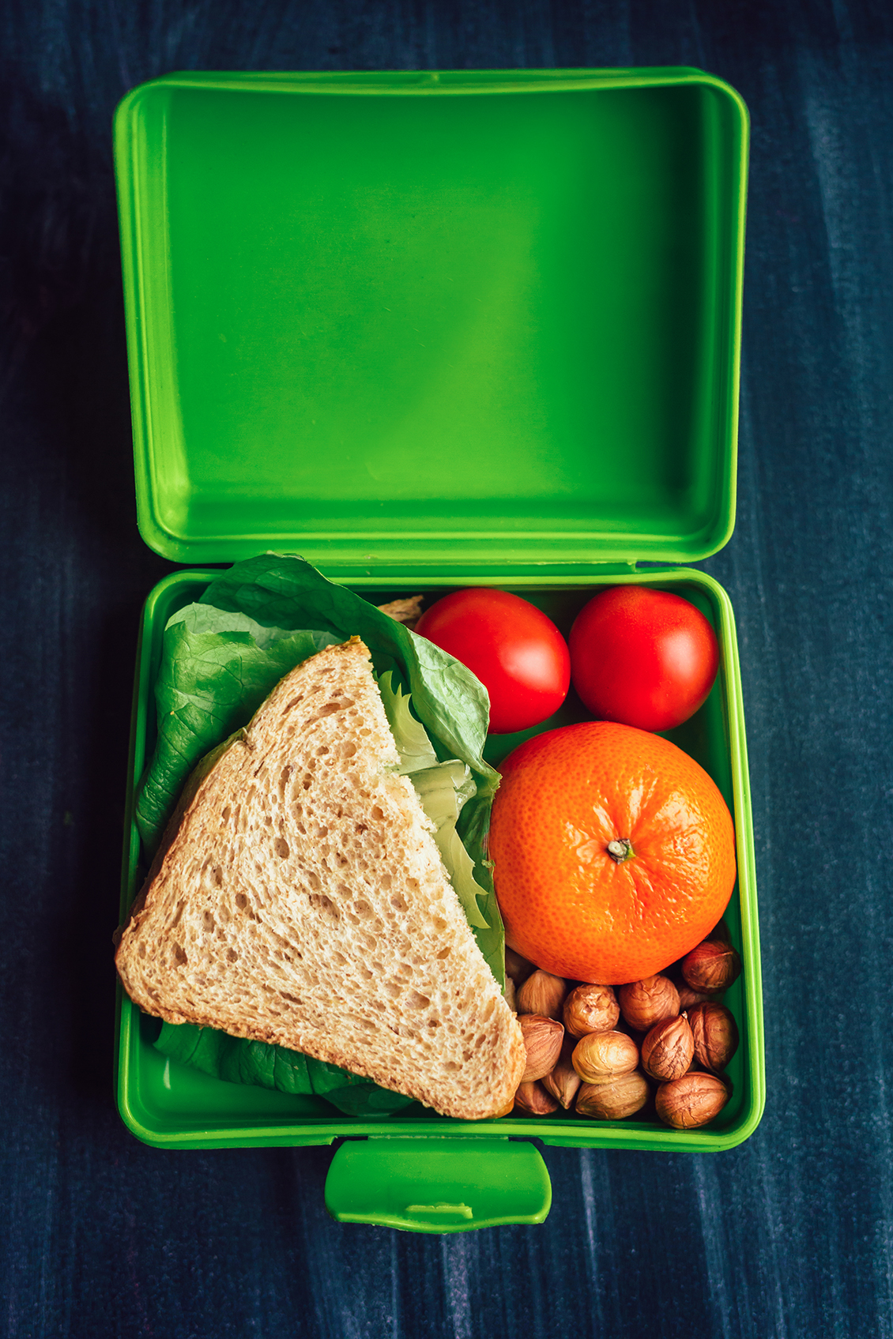
sESSION 3

HEALTHY

FOOD CHOICES

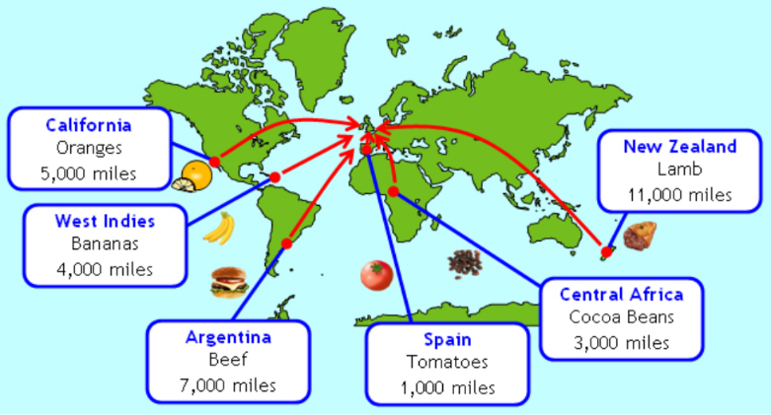
"Everything we eat has an impact on the planet" (Laura Tobin, 2022)
PLANNING YOUR PROJECT:

Research and find out more about how you can make sustainable and healthy food choices which will reduce the negative impact on the environment.
Think about the miles that food travels and alternative ways of reducing the carbon footprint of your food.
- What is food sustainability and why is it important? - BBC Bitesize
- Climate change food calculator: What's your diet's carbon footprint? - BBC News
- Lancashire's waste recycling is set to be revolutionised | Lancashire County Council News


SIGNPOSTING

If you have any questions or need any further support, remember you can always reach out to your trusted adults.

You can also reach out to the following places for more information and to speak to someone if you need to:


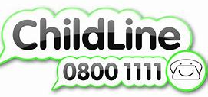

Voices of youth-UNICEF
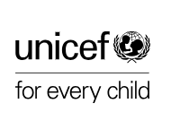

1 page Goals Comics - full set PDF (yumpu.com)
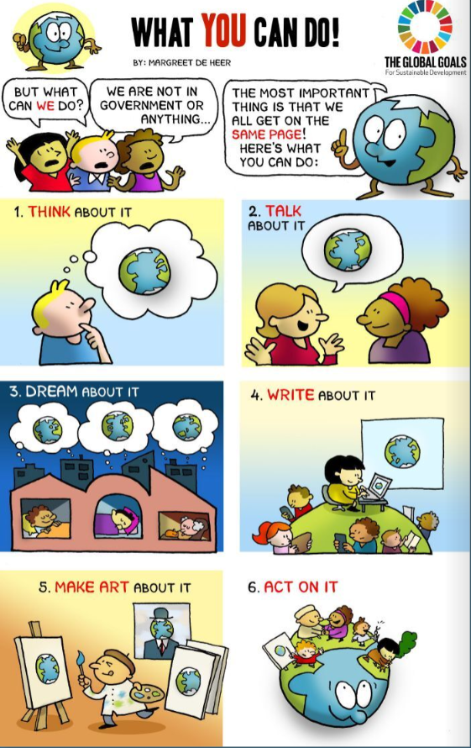

Heroes-For-Change.pdf (globalgoals.org)
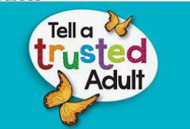
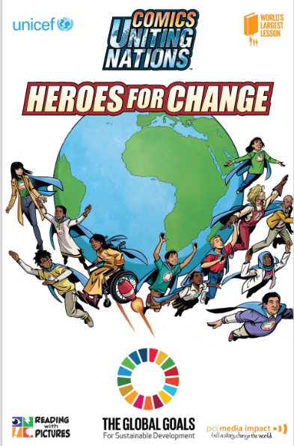

After completing your lessons, add any new learning below and consider what the key things you will take away from this half term:
How confidenat are you with sustainability and climate change NOW?
1 | 2 | 3 | 4 | 5 | 6 | 7 | 8 | 9 | 10
Sustainability and climate change

Key takeaways
- Takeaway #1: ________________________________________________________________________________________________________________________________________________
- Takeaway #2
________________________________________________________________________________________________________________________________________________

