Job Description

Directorate: | Resources
Service: | Finance
Location: | Preston / Hybrid
Salary range: | SCP 35-40 | Grade: | 10
Reports to: | Head of Service Pension Fund Client | Staff responsible for: | 2

Job purpose and scope
Experienced accounting professional providing specialist accountancy services to the Lancashire County Pension Fund. Regularly support/advise senior managers in all accounting matters associated with the Fund. Use of expertise to deal with highly complex tasks and issues across a range of situations.
Although working within well-defined functional objectives, the post holder will be expected to proactively question or challenge the Pension Fund's practices or procedure based on regulations, legislation or best practice. The post holder will manage a small team of finance professionals.

Performance Indicators
- Quality of advice/service against legal, safety and best practice standards
- Achievement of relevant service targets
- Adherence to internal/external quality standards if applicable
- Adherence to policies and procedures
- Accuracy and timeliness of information recording and processing
- Customer and stakeholder feedback
- Leading Lancashire Framework

Leading Lancashire – Our Leadership Framework
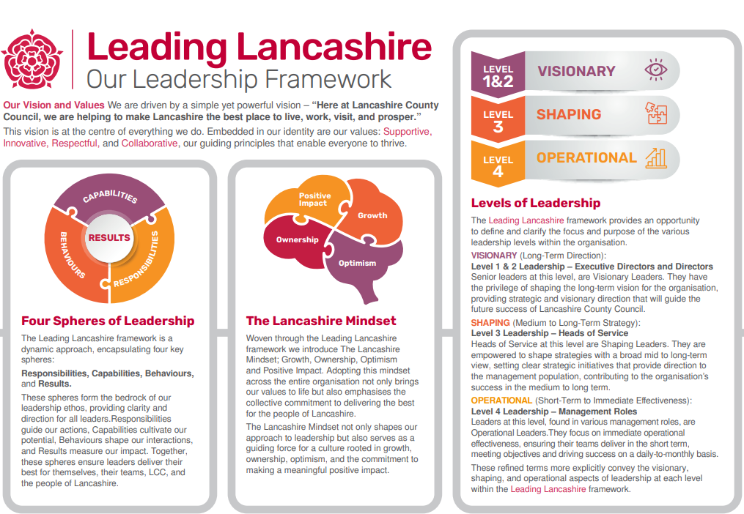

Accountabilities/Responsibilities
The following are a range of duties that are appropriate to this grade.

- Deliver and manage complex assignments to ensure regulatory compliance and achieve the best outcomes for the Pension Fund.
- Lead for the Pension Fund in the production of the financial statements and respond to audit queries in a timely manner.
- Lead for the Pension Fund in the budgetary cycle including budget development, in-year monitoring and year end reporting.
- Provide technical assurance and support the preparation of policies and procedures for the Pension Fund.
- Produce and analyse internal service and management information to contribute to the development of new services and innovative working practices.
- Liaise with the Pension Fund's investment pool to effectively manage and report on the Fund's investments and associated costs.
- Design, develop and deliver formal and informal technical training programmes for a range of audiences to ensure best practice is delivered across the service.
- Build partnerships/networks both internally and externally to shape and improve service delivery as well as use of best practice.

Other
- Equal Opportunities
We are committed to achieving equal opportunities in the way we deliver services to the community and in our employment arrangements. We expect all employees to understand and promote this policy in their work.

- Health and safety
All employees have a responsibility for their own health and safety and that of others when carrying out their duties and must help us to apply our general statement of health and safety policy.

- Customer Focused
We put our customers' needs and expectations at the heart of all that we do. We expect our employees to have a full understanding of those needs and expectations so that we can provide high quality, appropriate services at all times.

- Safeguarding Commitment
We are committed to protecting and promoting the welfare of children, young people and vulnerable adults.

- Skills Pledge
We are committed to developing the skills of our workforce. All employees will be supported to work towards a level 2 qualification in literacy and numeracy if they do not have one already.

Our Values
We expect all our employees to demonstrate and promote our values:

- Supportive
We are supportive of our customers and colleagues, recognising their contributions and making the best of their strengths to enable our communities to flourish.

- Innovative
We deliver the best services we possibly can, always looking for creative ways to do things better, putting the customer at the heart of our thinking, and being ambitious and focused on how we can deliver the best services now and in the future.

- Respectful
We treat colleagues, customers and partners with respect, listening to their views, empathising and valuing their diverse needs and perspectives, to be fair, open and honest in all that we do.

- Collaborative
We listen to, engage with, learn from and work with colleagues, partners and customers to help achieve the best outcomes for everyone.

Person Specification

All the following requirements are essential unless otherwise indicated by *

Your ability to meet the job requirements will initially be assessed by the information provided on your application but further assessment will be undertaken at interview and, in some cases, by using other types of assessment(s).

Qualifications
- Professionally qualified/relevant degree (or equivalent), plus substantial experience or substantial vocational experience demonstrating development through involvement in a series of progressively demanding roles.
Experience
- Experience of using up to date and authoritative knowledge in a technical/specialist area to support delivery of a complex operation/function/service.
- Working in different operational areas or supporting activity across different service.
- Experience of providing effective support for operational activity or service undergoing change and challenge.

Essential knowledge, skills & abilities
- Proven ability to implement and deliver complex and challenging solutions which are consistent with existing, new or evolving policy/procedure.
- Effective communication and networking skills with a wide range of staff and external organisations.
- Demonstrative knowledge of the application, principles, theory and practice of the specialist area of responsibility.
- Ability to apply technical/specialist judgement to ensure service area objectives are achieved.
- Ability to plan and organise a range of complex activities and priorities within a focused area of service.
- Comprehensive understanding of all existing Policy and Procedures in the service area and application in a changeable and challenging environment
- In addition to the skills knowledge and experience described above, you may be required to undertake a lower graded role as appropriate.
Other essential requirements
- Commitment to equality and diversity.
- Commitment to health and safety.
- Display the LCC values and behaviours at all times and actively promote them in others.

