Cold - Health Alert – Action Card

Who this action card is for

The Weather-Health Alert (WHA) system, provided by the UK Health Security Agency (UKHSA) and the Met Office, gives early warning to the health and social care sector, the responder community, the voluntary and community sector, and government departments when adverse temperatures (heat or cold) are likely to impact the health and wellbeing of the population, directly and indirectly.
This action card summarises the suggested actions that Providers should consider to prepare for, and respond to each Health Alert type.
These include actions to consider:
- all year round to support winter preparedness (Green)
- for pre-winter readiness and winter preparedness (Green)
- for a Yellow alert
- For an amber alert
- Or a red alert
Who is at risk?
Whilst exposure to cold weather can affect ANYONE, some service users are particularly at risk. These include: -
- older people (aged 65 years and over)
- anyone with long-term health conditions such as cardiovascular or respiratory disease, or a mental health condition
- pregnant women
- people at risk of falls
- people who live alone and may be unable to care for themselves.
- people who are housebound or have low mobility – even for a temporary period, e.g. after an operation or accident.
- people living in deprived circumstances or those struggling with the cost of living.
- young children (particularly those aged 5 and under)
- people with learning disabilities
Providers should be aware of the effects of cold weather on health, and when they notice a client at risk of cold, for example from living in a home that is too cold, should know what preventative and immediate actions to take to ensure the clients safety. Providers should have clear guidelines / and contact information to enable necessary arrangements (for example addressing housing issues) in the immediate and longer term.
Providers should carefully consider those actions that apply to the settings in which they work, for the health and wellbeing of their clients and staff but also ensure domiciliary staff are aware for the health and wellbeing of themselves and their clients .
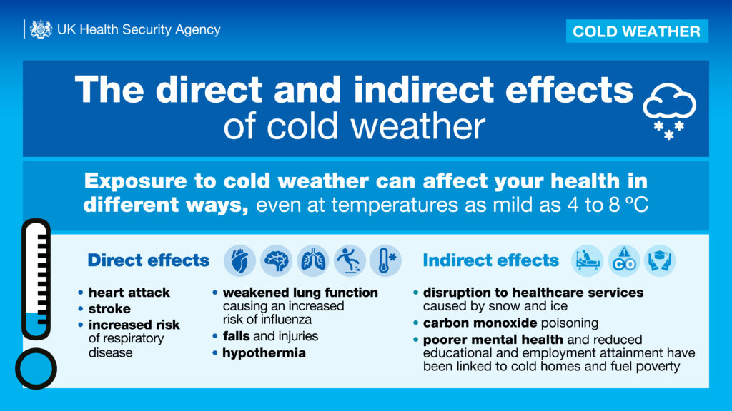
Using the action cards
Cold-Health Alerts (CHA) operate from 1 November to 30 March, although an out-of-season alert may still be issued if health impacts from cold weather are expected. The four alert levels, green, yellow, amber, and red indicate an escalating likelihood and impact on health, and potential disruption to healthcare and other services, as average temperatures drop to ≤2ºC or remain low for an extended period.

GREEN (preparedness) – no alert is issued as the conditions are likely to have minimal impact on health; it's business as usual but begin winter planning and preparedness activities.

YELLOW (response) – yellow alerts may be issued during periods of cold that are unlikely to impact most people but could impact anyone particularly vulnerable

AMBER (enhanced response) weather impacts likely to be felt across the whole health service – with greater risk to health of vulnerable groups (over 65's, those with health conditions or sleeping rough) and potential of risk to whole population including younger age groups. Non health sectors may observe impacts and a significant coordinated response may be required

RED (Emergency response) Indicates a significant risk to life even for the healthy population.

GREEN. | Winter planning and preparedness  No alert will be issued as the conditions are likely to have minimal impact on health. However, during periods when the risk is minimal, it is important that care homes/providers ensure that they have plans in place and are prepared to respond should a yellow alert be issued. All advice is applicable for care homes and domiciliary staff
GREEN. | Managers  - All providers to ensure staff are aware of the health alert system  - Provide staff with a copy of the Cold – Health Alert Action Card.  - Ensure services have up to date business continuity plans and staff know how to access them.  - Ensure all staff emergency contact details are up to date on oracle.  - Be aware of any staff who are at greater risk from the impacts of cold weather including.  - older people (aged 65 and above)  - people with cardiovascular (heart and circulation) conditions  - people with respiratory conditions (in particular, chronic obstructive pulmonary disease and childhood asthma)  - people with mental health conditions  - people with learning and/or physical disabilities  - pregnant women  - Ensure staff are aware of the health impacts of cold weather and how to keep warm and well.  - Remind staff to get their winter vaccinations if they are eligible, and to check staff news for details of the workforce flu plan and onsite clinic locations.  Staff  - Protect yourself and those around you by getting any winter vaccinations you are eligible for  - Contact your energy and water supplier and see if you are eligible to be added to their priority services register, a service that supports people in vulnerable situations .  - Have your coal, oil, wood or gas cooking or heating appliances checked /serviced by a registered engineer, make sure you have details of an engineer (just in case) and have boiler flues and chimneys checked for blockages and cleared if needed.  - Ensure any smoke alarms, and carbon monoxide detectors (EN 50291 compliant and fitted in the same room as boiler / heating appliances) are tested monthly and working properly.
YELLOW |  | Response  Yellow alerts may be issued during periods of cold weather which would be unlikely to impact most people. However, those who are particularly vulnerable (for example older people with multiple health conditions and on multiple medications, or those who are sleeping rough and at greater risk of cold exposure) are likely to struggle to cope in these conditions. A yellow alert may also be issued if the confidence in the weather forecast is low, but there could be more significant impacts if the worst-case scenario is realised.
Providers
- Remind staff about Cold - Health Alert Action Cards.
- Maintain regular contact with staff, particularly those who are more vulnerable.

Staff
- Keep an eye on the weather forecast, sign up for the Met Office weather alerts and take account of the weather when planning work over the following days. Where possible avoid exposing yourself to cold or icy outdoor conditions if you are at a higher risk of cold related illness or falls.
- Weather can change quickly – staff especially domiciliary carers should ensure someone knows where they are going, when they should arrive / return. Before setting out staff should consider carrying an emergency bag with warm clothes, a flask with a hot drink and some food in case they are affected by traffic disruption. Make sure phones are fully charged and ensure cars are ready for winter, check lights and tyre pressures, top up anti-freeze and carry de icer and a torch. Be cautious in car parks too, they may not be gritted.
- Check which roads are usually gritted – this may inform your route Our gritting routes - Lancashire County Council
- When working in a care home or at a client's home, ideally heat your home or the rooms where you spend most time to at least 18⁰C (65ºF)
- Wear several layers of thinner clothing rather than one thick layer.
- Reminder - try not to sit still for more than an hour, walk around or do some seated exercises if you can and get a hot drink. Encourage service users to move wherever possible
- Domiciliary carers – advise clients to keep your home warm, reduce draughts around windows and doors and keep bedroom windows closed at night.
- Keep some cold remedies and enough prescription medicines, order them in plenty of time.
- Make sure clients have enough food and water for a few days in case you can't get there or pipes freeze.
- Advise client to wear well-fitting warm slippers to avoid trips and falls at home and if staff need to venture out in icy weather wear footwear with a good grip.

AMBER | Enhanced Response  An amber alert represents a situation in which the expected impacts are likely to be felt across the organisation, with potential for the whole population to be at risk. Other sectors, apart from health and social care (for example transport) may also start to observe impacts, indicating that a coordinated response is required. In addition, in some circumstances a National Severe Weather Warning Service (NSWWS) warning may be issued for snow, ice or wind in conjunction with and aligned to the Cold Health Alert. This situation would indicate that significant impacts are expected across multiple sectors.
AMBER | Providers  Keep in contact with the contracts team alerting them to any ongoing or potential issues that may impact continuity of service or the health of service users .  - Ensure you/ staff are aware of any risk assessment for and response to cold weather that has been carried out.  - Providers to determine how and where to prioritise travel, especially if ice and/or snow occur.  - consider which, if any, service activity can be suspended until more clement weather returns.  If you/your staff work in a fixed site in the community or for a service that delivers care to people in their homes:  - increase advice on ways of identifying those at risk from cold and ways to manage their needs, drawing on UKHSA guidance for adult social care managers and healthcare providers, and general population messages as appropriate  - Reinforce cold weather health risks/advice to staff and clients to help reduce risks from cold exposure – using resources such as UKHSA’s Keeping warm and well in cold weather poster  - ensure that high-risk individuals are actively monitored during cold weather episodes, and that those most vulnerable to cold-related illnesses have visitor or phone call arrangements in place

RED | Emergency Response  A red alert would indicate significant risk to life for everyone, including the healthy population. Severe impacts would be expected across all sectors, and a coordinated response is essential. The UK government will declare an emergency if there is severe or prolonged cold weather affecting sectors other than health and social care, and if the conditions require a coordinated multi-agency response.
RED | Providers.  - follow all contingency plans and remain in regular contact with the contracts team alerting them to any issues.  - monitor service impact and escalate any concerns to the contract team  - consider whether a risk assessment for and response to cold weather is required for your service/function  - support staff to determine how and where to prioritise travel  - continue other actions as per amber alert above unless advised to the contrary  If your staff deliver care to people in their homes:  - increase advice to staff on ways of identifying those at risk from cold, and ways to manage their needs, drawing on UKHSA guidance for adult social care managers and healthcare providers, and general population messages as appropriate  - ensure that high-risk individuals are actively monitored during cold weather episodes, and that those most vulnerable to cold-related illnesses have visitor or phone call arrangements in place

Other Actions & Resources
Long-term, strategic actions
Providers should consider the following:
Identify those at risk
If you provide a service delivering care to people in their homes, establish methods to identify, alert and monitor individuals most vulnerable to cold-related illnesses. Methods for identifying vulnerable people should include reference to clinical advice if staff are unsure whether someone is at risk. Ensure this information is shared with friends/ family others helping to care for an individual, considering their needs and what care they may be able to give in the event of adverse cold weather.
Work to identify those at risk may include developing and maintaining a register of the most vulnerable individuals.
Ensure that staff are prompted to signpost vulnerable people to relevant sources of support to help protect them from cold (for example for energy efficiency measures, benefits or related advice).

Work with partners.
Providers work with partners and other services as appropriate to coordinate business continuity plans and/or cold weather plans, ensuring vulnerable and marginalised groups are appropriately supported and are involved in the planning process.

