Job Description

Directorate: | Resources
Service: | Facilities Management
Location: | Preston
Salary range: | SCP 35-40 | Grade: | 10
Reports to: | Head of School and Residential Care Catering | Staff responsible for: | 1

Job purpose and scope
To lead the strategic growth and commercial development of the Schools Catering Service, increasing market share, securing new contracts, strengthening customer retention and delivering sustainable income growth.

The postholder will identify and develop new business opportunities, lead commercial negotiations, oversee bids and tenders, manage strategic customer relationships and direct marketing activity to ensure the long-term success and sustainability of the traded service.

The role will act as the commercial lead for business growth whilst working closely with operational managers to ensure customer requirements are translated into successful service delivery.

Performance Indicators
The postholder will typically be measured against:

- Growth in traded income.
- Number and value of new contracts secured.
- Customer retention rates.
- Market share growth.
- Tender success rates.
- Customer satisfaction levels.
- Sales pipeline value.
- Delivery of marketing and growth plans.

Leading Lancashire – Our Leadership Framework
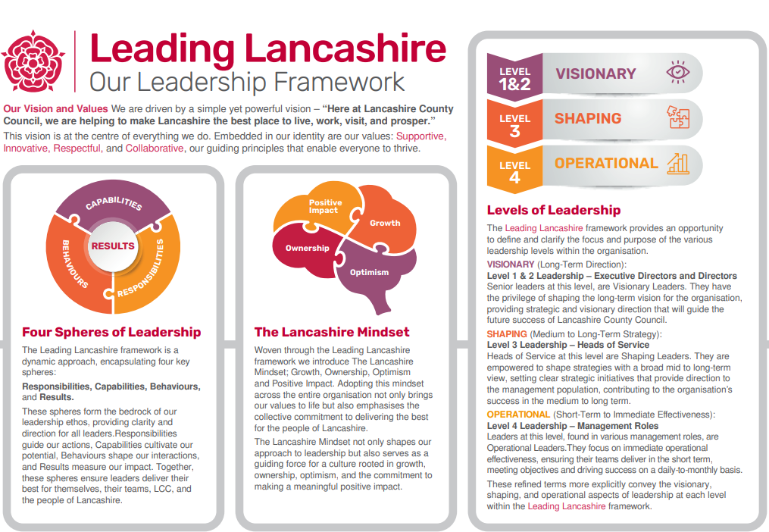

Accountabilities/Responsibilities
Business Growth & Commercial Development
- Develop and deliver a business growth strategy aligned to the service's commercial objectives.
- Identify, evaluate and pursue new business opportunities.
- Develop and maintain a pipeline of prospective customers.
- Research market trends, competitor activity and customer requirements.
- Produce business cases and growth plans to support service expansion.
- Identify opportunities to diversify and expand the service offer.

Customer Acquisition & Retention
- Lead activities to secure new schools, academies and Multi-Academy Trust customers.
- Build strong relationships with Headteachers, School Business Managers, Trust Leaders and Governors.
- Manage strategic customer accounts.
- Lead customer retention and contract renewal initiatives.
- Conduct customer engagement and satisfaction reviews.
- Develop customer loyalty programmes and retention strategies.

Tenders, Bids & Contract Negotiation
- Lead the preparation and submission of tenders, bids and competitive proposals.
- Coordinate bid teams and subject matter experts.
- Manage commercial presentations and customer pitches.
- Lead contract negotiations within approved governance arrangements.
- Ensure all proposals are commercially robust and aligned with service objectives.

Marketing & Communications
- Line manage and support the Marketing Officer.
- Develop annual marketing and communication plans.
- Direct promotional campaigns, events and customer engagement initiatives.
- Grow awareness of the Schools Catering Service brand.
- Ensure effective use of digital marketing, social media and customer communications.

Commercial Performance Management
- Deliver agreed business growth and income targets.
- Monitor key performance indicators relating to growth, retention and customer acquisition.
- Report progress to senior management and stakeholders.
- Support budget planning and forecasting activities.
- Contribute to service planning and commercial strategy development.

Partnership & Stakeholder Management
- Develop strategic partnerships with schools, academies, trusts and other organisations.
- Represent the service at networking events, conferences and stakeholder meetings.
- Maintain awareness of developments within the education sector.
- Promote the service as a trusted and high-quality provider.

General Responsibilities:
- Comply with all Council policies and procedures.
- Promote equality, diversity and inclusion.
- Ensure compliance with health and safety requirements.
- Support organisational change and continuous improvement initiatives.
- Undertake other duties commensurate with the level of responsibility of the post.

Other
- Equal Opportunities
We are committed to achieving equal opportunities in the way we deliver services to the community and in our employment arrangements. We expect all employees to understand and promote this policy in their work.

- Health and safety
All employees have a responsibility for their own health and safety and that of others when carrying out their duties and must help us to apply our general statement of health and safety policy.

- Customer Focused
We put our customers' needs and expectations at the heart of all that we do. We expect our employees to have a full understanding of those needs and expectations so that we can provide high quality, appropriate services at all times.

- Safeguarding Commitment
We are committed to protecting and promoting the welfare of children, young people and vulnerable adults.

- Skills Pledge
We are committed to developing the skills of our workforce. All employees will be supported to work towards a level 2 qualification in literacy and numeracy if they do not have one already.

Our Values
We expect all our employees to demonstrate and promote our values:

- Supportive
We are supportive of our customers and colleagues, recognising their contributions and making the best of their strengths to enable our communities to flourish.

- Innovative
We deliver the best services we possibly can, always looking for creative ways to do things better, putting the customer at the heart of our thinking, and being ambitious and focused on how we can deliver the best services now and in the future.

- Respectful
We treat colleagues, customers and partners with respect, listening to their views, empathising and valuing their diverse needs and perspectives, to be fair, open and honest in all that we do.

- Collaborative
We listen to, engage with, learn from and work with colleagues, partners and customers to help achieve the best outcomes for everyone.

Person Specification

All the following requirements are essential unless otherwise indicated by *

Your ability to meet the job requirements will initially be assessed by the information provided on your application but further assessment will be undertaken at interview and, in some cases, by using other types of assessment(s).

Qualifications
- Degree-level qualification in Business, Marketing, Commercial Management or a related discipline, or equivalent relevant experience.
- Evidence of continuing professional development (CPD).
- Chartered Institute of Marketing (CIM) qualification.*
- MBA or postgraduate business qualification.*
- Commercial Management qualification.*
- Business Development or Sales qualification.*
- Project Management qualification.*
Experience
- Significant experience in business development, commercial growth, sales, account management or market development.
- Proven track record of generating business growth and securing new customers or contracts.
- Experience of developing and delivering growth strategies.
- Experience of preparing and presenting commercial proposals, bids or tenders.
- Experience of building relationships with senior stakeholders and decision-makers.
- Experience of managing staff, projects or commercial initiatives.
- Experience within education, catering, hospitality, facilities management or other traded service environments. *
- Experience working with schools, academies or Multi-Academy Trusts (MATs).*
- Experience of public sector procurement or tendering.*
- Experience within local government or other public sector organisations.*

Essential knowledge, skills & abilities
Commercial Skills
- Strong commercial awareness.
- Market analysis and business planning.
- Financial and commercial evaluation skills.
- Negotiation and influencing skills.

Business Development
- Customer acquisition and retention.
- Bid and tender management.
- Opportunity identification and conversion.

Communication
- Excellent presentation skills.
- Strong written communication skills.
- Report writing and proposal preparation
- Ability to communicate effectively with senior stakeholders.

Leadership
- Staff management and development.
- Coaching and mentoring.
- Project management.
- Performance management.

Other essential requirements
- Commitment to equality and diversity.
- Commitment to health and safety.
- Display the LCC values and behaviours at all times and actively promote them in others.
- This is an essential car user post
You will be required to provide a car for use in connection with the duties of this post and must be insured for business use. In certain circumstances consideration may be given to applicants who, as a consequence of a disability, are unable to drive

