Job Description

Directorate: | Resources
Service: | Finance
Location: | Preston/Hybrid
Salary range: | £55,612 - £60,147 | Grade: | 12
Reports to: | Head of Service Corporate Finance | Staff responsible for: | 4

Job purpose and scope
This role will focus on leading the financial accounts production for the council including consolidating the council's owned company into the Council's group accounts.

Performance Indicators
- Quality of advice/service against legal, safety and best practice standards
- Achievement of relevant service targets
- Adherence to internal/external quality standards if applicable
- Adherence to policies and procedures
- Accuracy and timeliness of information recording and processing
- Customer and stakeholder feedback
- Leading Lancashire Framework

Leading Lancashire – Our Leadership Framework
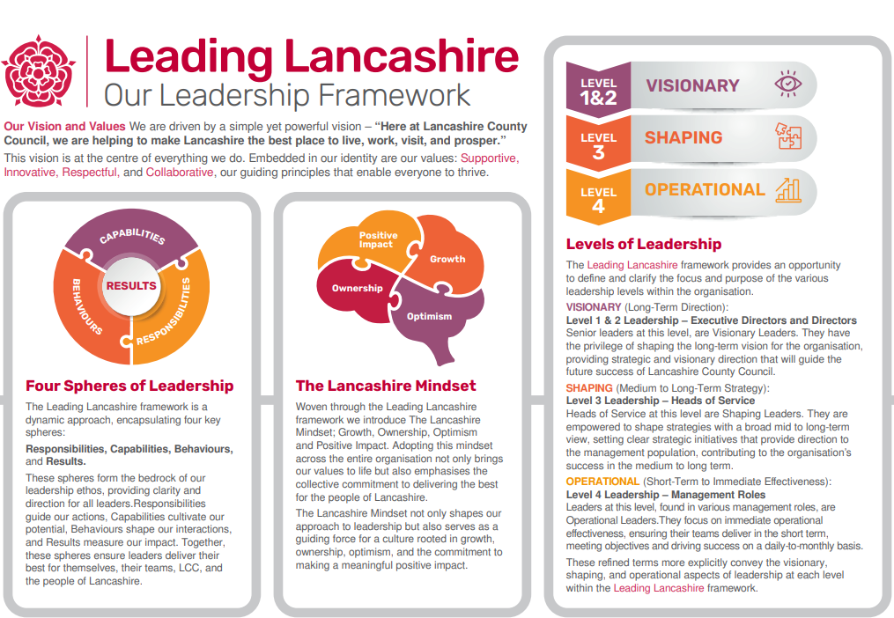

Accountabilities/Responsibilities
- Co-ordinate and manage the production of the Council's annual statement of accounts by the statutory deadline, including the design and implementation of a closure plan.
- Act as a key point of contact for the council's external auditors on audit work to facilitate and/or response to audit enquiries.
- Ensuring the integrity/maintenance of the Council’s core accounting systems and records throughout the year, to support the production and reporting of accurate financial accounting information in line with the appropriate financial regulations.
- Advise on the Council’s chart of accounts so that they are in accordance with best practice to support the financial reporting requirements of the Council
- Manage the production of the Council's annual return for the Whole of Government accounts.
- Responsible for the oversight and interpretation of the Council’s Balance Sheet to provide advice on proper financial reporting on balance sheet matters.
- Providing managerial leadership and oversight to the core accounting function.
- Keeping abreast of the core government and financial regulations applicable to local government finance and ensuring that senior officers are briefed on the implications of proposed changes to financial reporting requirements and other relevant sectoral issues.
- Carry out or lead time-limited projects or tasks to deliver specific improvements and to manage staff as required.
- Exert and significantly influence decisions at senior level within own area of responsibility.

Other
- Equal Opportunities
We are committed to achieving equal opportunities in the way we deliver services to the community and in our employment arrangements. We expect all employees to understand and promote this policy in their work.

- Health and safety
All employees have a responsibility for their own health and safety and that of others when carrying out their duties and must help us to apply our general statement of health and safety policy.

- Customer Focused
We put our customers' needs and expectations at the heart of all that we do. We expect our employees to have a full understanding of those needs and expectations so that we can provide high quality, appropriate services at all times.

- Safeguarding Commitment
We are committed to protecting and promoting the welfare of children, young people and vulnerable adults.

- Skills Pledge
We are committed to developing the skills of our workforce. All employees will be supported to work towards a level 2 qualification in literacy and numeracy if they do not have one already.

Our Values
We expect all our employees to demonstrate and promote our values:

- Supportive
We are supportive of our customers and colleagues, recognising their contributions and making the best of their strengths to enable our communities to flourish.

- Innovative
We deliver the best services we possibly can, always looking for creative ways to do things better, putting the customer at the heart of our thinking, and being ambitious and focused on how we can deliver the best services now and in the future.

- Respectful
We treat colleagues, customers and partners with respect, listening to their views, empathising and valuing their diverse needs and perspectives, to be fair, open and honest in all that we do.

- Collaborative
We listen to, engage with, learn from and work with colleagues, partners and customers to help achieve the best outcomes for everyone.

Person Specification

All the following requirements are essential unless otherwise indicated by *

Your ability to meet the job requirements will initially be assessed by the information provided on your application but further assessment will be undertaken at interview and, in some cases, by using other types of assessment(s).

Qualifications
- Professional and/or academic level qualification or equivalent or substantial vocational experience in a relevant technical, scientific, specialised or operational field
Experience
- Significant experience in a senior technical/specialist advisory role within a large and/or complex operation/function/service
- Significant experience of working across services within multidisciplinary teams; managing projects and teams outside of direct line management
- Initial strategy, policy and procedural development and implementation across the area of responsibility
- Innovative and creative management of services within a changing and challening financial environment

Essential knowledge, skills & abilities
- Ability to build relationships and influence, develop and motivate at senior levels, internally and externally
- Significant knowledge of the application, principles, theory and practice of the specialist area of responsibility
- Comprehensive understanding of Corporate and service strategy and objectives and translation and implementation at local level
- Ability to apply managerial judgement to ensure service area objectives are achieved
- Strong analytical and problem solving skills and the ability to look ahead and understand implications of future initiatives within the area of responsibility
- Strong project and change management skill
Other essential requirements
- Commitment to equality and diversity.
- Commitment to health and safety.
- Display the LCC values and behaviours at all times and actively promote them in others

