Job Description

Directorate: | Education & Children's Services
Service: | Education Improvement
Location: | County Hall / Hybrid
Salary range: | £66,336 - £72,150 | Grade: | 13
Reports to: | Head of Education Improvement | Staff responsible for: | Up to 8

Job purpose and scope
To act as a Senior Manager for Education Improvement with line management responsibilities for early years sufficiency, early years quality assurance, outdoor education, education management system lead, Families First Education officer and educational visits. Responsible for providing expert advice, strategic direction and professional leadership to support corporate priorities and statutory duties. Working with the Head of Service, the post holder will shape and deliver strategy, influence senior decision-making, and lead complex, high-impact initiatives to ensure effective, sustainable education provision.

Performance Indicators
Strategic Leadership
- Delivery of a clear early years strategy, as part of the education strategy
- Influence on key policy, funding, and investment decisions.
- Provide strategic oversight of the budgets for these teams.
- Alignment with corporate and transformation priorities.
- Developing and implementing strategic business plans in line with the core
purpose and objectives of Education Improvement Services.
- Leading the delivery of service objectives and collaborating with partners to deliver
multi-agency initiatives.
- Leading, developing, and promoting a culture of continuous professional
development for all staff.
- Ensuring robust systems are in place to maintain and produce accurate and timely
data for statutory compliance and evaluation of service delivery.
- Engaging with partners and stakeholders to advocate and raise the profile of
Lancashire's Education Improvement Services.
- Influencing key decision makers at senior levels, both internal and external to the council.
- Stakeholder Leadership:
  - Strong partnerships with schools, trusts, and DfE
  - Effective multi-agency collaboration
  - Positive stakeholder engagement

- Political engagement and responsibilites including drafting and delivering briefings on
subjects under line managerment
Organisational Leadership
• High-performing, accountable team
• Culture of innovation and continuous improvement
• Delivery of efficiency and service improvements
Leading Lancashire – Our Leadership Framework
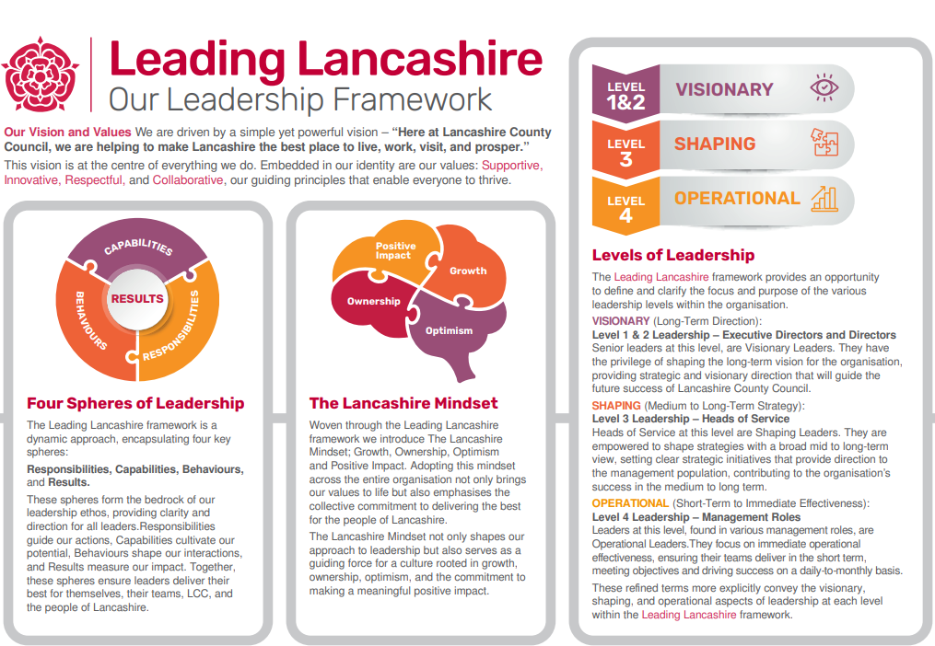

Accountabilities / Responsibilities
- Support with the delivery of the education strategy ensuring statutory sufficiency and alignment with corporate priorities.
- Provide authoritative advice and influence senior decision-making through robust analysis and technical expertise.
- Oversee forecasting, data integrity, and intelligence to underpin effective planning and risk management.
- Direct the delivery of education infrastructure and capital programmes, ensuring outcomes are achieved on time and within budget.
- Build and lead strong partnerships across schools, trusts, government, and developers to secure provision.
- Maintain public confidence through transparent communication and high-quality stakeholder engagement.
- Drive innovation, continuous improvement, and service transformation.
- Lead and develop a high-performing team, ensuring accountability, compliance, and delivery of service objectives.
- To lead the development and implementation of quality assurance strategies, ensuring alignment with demographic need, deprivation indicators, inclusion priorities, and wider council and partnership objectives.
- To lead and oversee education support services, including educational visits and outdoor education, ensuring robust systems, policies, and assurance mechanisms are in place to maintain safety, compliance, and high-quality learner experiences.
- To drive the strategic development and effective use of education management systems, ensuring data integrity, system optimisation, and alignment with service delivery needs to support informed decision-making and performance monitoring.
- To work across organisational boundaries to deliver integrated approaches, linking early years provision, quality assurance, inclusion, traded services, and wider education improvement priorities, ensuring coherence across the system.

Other
- Equal Opportunities
We are committed to achieving equal opportunities in the way we deliver services to the community and in our employment arrangements. We expect all employees to understand and promote this policy in their work.

- Health and safety
All employees have a responsibility for their own health and safety and that of others when carrying out their duties and must help us to apply our general statement of health and safety policy.

- Customer Focused
We put our customers' needs and expectations at the heart of all that we do. We expect our employees to have a full understanding of those needs and expectations so that we can provide high quality, appropriate services at all times.

- Safeguarding Commitment
We are committed to protecting and promoting the welfare of children, young people and vulnerable adults.

- Skills Pledge
We are committed to developing the skills of our workforce. All employees will be supported to work towards a level 2 qualification in literacy and numeracy if they do not have one already.

Our Values
We expect all our employees to demonstrate and promote our values:

- Supportive
We are supportive of our customers and colleagues, recognising their contributions and making the best of their strengths to enable our communities to flourish.

- Innovative
We deliver the best services we possibly can, always looking for creative ways to do things better, putting the customer at the heart of our thinking, and being ambitious and focused on how we can deliver the best services now and in the future.

- Respectful
We treat colleagues, customers and partners with respect, listening to their views, empathising and valuing their diverse needs and perspectives, to be fair, open and honest in all that we do.

- Collaborative
We listen to, engage with, learn from and work with colleagues, partners and customers to help achieve the best outcomes for everyone.

Person Specification

All the following requirements are essential unless otherwise indicated by *

Your ability to meet the job requirements will initially be assessed by the information provided on your application but further assessment will be undertaken at interview and, in some cases, by using other types of assessment(s).

Qualifications
- Professional qualification at Level 6+ in related discipline
- Evidence of continuous professional development
- Management qualification or significant management training or commitment to work towards
- Qualified Teacher Status*
Experience
- Proven senior-level experience in education
- Track record of delivering strategic change in teams / services
- Experience working with schools, trusts, DfE, and stakeholders
- Experience of advising senior leaders and elected members
- Experience of leading and managing a team through a period of change
Essential knowledge, skills & abilities
- Ability to work across the service to ensure less duplication and more collaboration
- Demonstrates authoritative knowledge of interpretation of local data to inform strategic decision-making and ensure sufficient high-quality provision.
- Applies a strong understanding of early years legislation, statutory duties (including Childcare Acts), regulatory frameworks, and quality standards (including Ofsted and EYFS requirements) to ensure compliance, promote continuous improvement, and support high standards across provision.
- Ability to operate with substantial experience within a complex local authority environment, providing credible, evidence-based advice and strategic direction across early years services, traded services, and education support functions that influence both operational delivery and long-term planning.
- Ability to demonstrate well-established capability in multi-agency and sector partnership working, effectively influencing early years providers, schools, academy trusts, health partners, and private / voluntary sector organisations to deliver coordinated and sustainable outcomes.
- Ability to provide authoritative and confident leadership at a senior level, contributing to key decision-making forums and producing high-quality briefings and reports for senior leaders, elected members, and scrutiny, particularly in relation to early years outcomes, service performance, and traded activity.
- Ability to operate in a proactive leadership capacity across a broad portfolio, identifying risks and opportunities relating to early years quality, sufficiency, educational visits compliance, outdoor education provision, and traded services sustainability, and initiating solutions to strengthen service delivery.
- Ability to exercise sound judgement in complex and sensitive situations, balancing competing priorities such as financial pressures, market sustainability, safeguarding responsibilities, and stakeholder expectations.
- Ability to maintain a strong focus on delivery and outcomes, ensuring that early years sufficiency, quality improvement, service compliance (including educational visits), and traded service objectives are achieved through effective leadership, performance management, and continuous improvement.

Other essential requirements
- Commitment to equality and diversity.
- Commitment to health and safety.
- Display the LCC values and behaviours at all times and actively promote them in others.
- This is an essential car user post

You will be required to provide a car for use in connection with the duties of this post and must be insured for business use. In certain circumstances consideration may be given to applicants who, as a consequence of a disability, are unable to drive

