TOWN AND COUNTRY PLANNING ACT 1990 (AS AMENDED)

HIGHWAYS REBUTTAL BY
RYAN DERBYSHIRE MCIHT

On behalf of

LANCASHIRE COUNTY COUNCIL

Against

JIM BUDD

Witness for

Baxter Group Limited on

HIGHWAYS

MYTAX FARM, 4 BOURBLES LANE, POULTON-LE-FYLDE, FY6 0PE

THE EXTRACTION AND PROCESSING OF SAND AND GRAVEL INCLUDING THE CONSTRUCTION OF NEW SITE ACCESS ROADS, LANDSCAPING AND SCREENING BUNDS, MINERALS WASHING PLANT AND OTHER ASSOCIATED INFRASTRUCTURE WITH RESTORATION TO LEISURE END-USES, AGRICULTURAL LAND AND BIODIVERSITY ENHANCEMENT, USING IMPORTED INERT FILL.

PLANNING INSPECTORATE REF: APP/Q2371/W/25/6002168

LOCAL PLANNING AUTHORITY REF: LCC/2023/0030

APRIL 2026
Introduction

  - This Rebuttal relates to issues raised in the highway proof of evidence submitted by Mr Jim Budd, on behalf of the Appellant (Baxter Group Limited) in regards to the appeal proposal at Mytax Farm, 4 Bourbles Lane, Poulton-le-Fylde.

  - I have focussed my evidence within this Rebuttal on the matters where I consider Rebuttal evidence would most assist the Inquiry and the Inspector. However, this should not be taken as a concession that I accept the other parts of the proof of evidence submitted by Mr Budd which I do not comment on here.

  - The structure of my rebuttal is as follows:
- Section 2 defines the highway extents along Lancaster Road and explains why the certain pieces of information provided within Mr Budd's proof cannot be relied upon when defining the highway extents.
- Section 3 rebuts Mr Budd's claim that the vehicular visibility splays at the proposed site access can be provided within the Appellants control and Highway boundary.
- Section 4 set outs why Lancaster Road needs to be widened, which rebuts Mr Budd's opinion.
- Section 5 provides an assessment on Mr Budd's proposed mitigation strategy.
- Section 6 rebuts Mr Budd's claim that the proposal will have no material impact on vulnerable road users.
- Section 7 presents my conclusions.

- Defining the Highway Extents

  - In In paragraphs 4.4-4.5 of Mr Budd's Proof of Evidence, Mr Budd refers to Appendix JRB1 as “the official extent of the adopted highway records” and then overlays this information onto a topographical survey in Appendix JRB2. He argues that this produces an accurate representation of the adopted highway along Lancaster Road. That conclusion is incorrect.

  - Although required to maintain a list of streets there is no statutory requirement for the Highway Authority to know the precise extents of highway, maintainable at public expense.

  - However, I am advised that the issue of highway extent is to be considered in the following way. Firstly, a determination must be reached as to whether or not the hedge was grown by reference to the highway. This would usually arise by an act of the landowner to separate his land from the highway and keep his stock from straying onto the highway, but it could arise from actions of a Highway Authority itself in the case of highways which were created under statutory authority or through the acquisition of land for that purpose. The question whether or not the fence or hedge was created for that reason may be the subject of direct evidence or it may be an inference to be drawn from a number of factors.

  - In the present case, it is Lancashire County Councils view that the hedge was grown by reference to the highway. This inference is drawn from Lancashire County Council having no record of cutting or maintaining the hedges along Lancaster Road, and that the space between the hedgerows on either side would historically have provided the width needed for carts and carriages to pass with there being no available highway space to create a footway, for example. This section of highway predates 1786, when the first highways plan showing this area was produced by Yates.

  - This evidence gives rise to the "hedge to hedge" presumption, with the highway being taken to extend to the carriageway side of the rootstock of the boundary hedge. As such hedges do not form part of the highway and are not highway assets. They are private assets.

  - The Maintainable at Public Expense (MAPE) layer within the County Councils mapping system "Mapzone" is drawn on top of a modern digitised Ordnance Survey (OS) base map. Although it is not wholly accurate.

  - A more accurate base map would require topographically surveying every road in Lancashire, with each survey involving detailed site investigation and precise on the ground measurement. Only then could a bespoke adoption overlay be created for each individual road. However, undertaking such surveys across the entire network is not feasible with current resources, which is why OS‑based mapping is used for practical purposes and to provide a snapshot of our internal records.

  - I do recognise that the Appellant references an extract from Lancashire County Council’s internal mapping software, Mapzone, issued in 2020 showing the indicative highway extents along Lancaster Road. However, at the time of issue, the extract was accompanied by the standard disclaimer, which reads:

"Whilst the information provided is believed to be correct, based on the evidence currently available to the authority, the extent of the adopted highway can be evidenced from various sources and our records are not a conclusive record of rights. The record of highway extent and the List of Streets can be amended if there is sufficient evidence to support a different conclusion.”

  - The disclaimer makes it clear that the extract is indicative only, not definitive evidence of highway extents or record of rights and may be amended if further evidence becomes available.

  - When comparing OS maps to site specific topographical surveys, discrepancies are not uncommon and are to be expected. For this reason, taking an OS based MAPE layer extract and superimposing it onto an accurate topographical survey, as Mr Budd has done in Appendix JRB2, creates a false impression of precision. The two datasets are produced to different standards, for different purposes, and with different tolerances. Expecting them to align exactly is technically unsound.

  - Therefore, Appendix JRB2 cannot be relied upon as an accurate representation of the adopted highway extent and instead the "hedge to hedge" presumption should continue to be used when seeking to define the highway extents.

  - Mr Budd recognises that any highway mitigation works need to be "deliverable within the adopted highway" (Paragraph 4.54). However, no site-specific investigation of the actual highway extents has been undertaken, despite this being requested within my statutory comments (Appendix 1 and 2). As a result, it remains unclear whether it is feasible or deliverable to widen the carriageway by 0.6m as proposed within the existing highway boundary along Lancaster Road (Turner Lowe submission), as well as safely positioning the proposed signage along Lancaster Road and the A588.

  - The same problem also exists in relation to the proposal to widen the southern extents of Lancaster Road only, as now put forward in Mr Budd’s proof and shown on SCP drawing SCP/260086/D04 (Appendix JRB14).

  - However, part of the SCP proposal which seeks to widen the southern extents of Lancaster Road by 1.4m near the Vine House bend, which would require the removal of approximately 60m of privately owned hedgerow cannot be delivered without a suitable legal agreement with the landowner or by the Appellant acquiring more land. This is also something that to my knowledge has not been ecologically assessed.

- Proposed Site Access

  - In paragraph 4.37, Mr Budd states that “the normal visibility splay requirement for new junctions onto a 30mph road is 2.4m x 43m". As set out in paragraphs 5.4 and 5.5 of my proof, visibility splays based on the posted speed limit can only be accepted where an effective and deliverable scheme is provided and evidenced to ensure speed compliance. In the absence of such a scheme, the recorded 85th percentile speeds must be used to determine the minimum visibility requirements as it is applicable to the speeds drivers are travelling as opposed to a theoretical ideal.

  - Mr Budd then refers to earlier discussions with the previous transport consultant, during which Lancashire County Council accepted a reduced setback distance of 1.2m.

  - To clarify I did accept that a reduced setback distance could be appropriate if the access were to be used exclusively by HGVs. However given the proposed access will serve all vehicle types, the standard 2.4m setback must be applied to reflect the differing driver positions and eye heights across the full range of vehicles.

  - In paragraph 4.41, Mr Budd then cites SCP drawing number 260086-D05 (Appendix JRB7), which he claims demonstrates that the required visibility splays can be achieved within land under the Appellant’s control and the adopted highway, subject to cutting back vegetation within the highway boundary.

  - However, the hedge immediately to the west of the proposed site access is not within the control of the Highway Authority or the Appellant. It is in the control of a different landowner with the highway extents being based off the root stock of the hedge, as described in Section 2 above. Therefore, the Appellant without a suitable legal agreement with the landowner or by purchasing appropriate land is unable to fully prevent any obstructions higher than 1m, impacting visibility splays to the west, as stated within Section 5 of my proof. This means that they cannot deliver the visibility splays required to achieve a safe site access, which presents an unacceptable highway safety risk, contrary to paragraph 116 of the NPPF, Policy DM2 of the Joint Lancashire Minerals and Waste Local Plan and Policy CDMP6 of the Wyre Local Plan.

- Is there a need to widen the carriageway along Lancaster Road?

  - In paragraph 4.54, Mr Budd states that he does not consider that widening works are required due to Lancaster Road already accommodating two-way HGV movements, the absence of recorded accidents and the modest amount of HGV traffic generated by the development.

  - I disagree with his opinion as the proposal will significantly intensify the use of Lancaster Road with up to 120 two-way HGV movements occurring per day as stated within the Highway Statement of Common Ground and within paragraph 3.15 of the Updated Transport Statement (December 2024). This is in a location where two-way HGV movements are not possible along the full extents of Lancaster Road as demonstrated in my evidence.

  - By using Mr Budd's methodology as stated within paragraph 5.11, and illustrated in Appendix JRB15, for two-way HGV movements to occur along a straight section of road, the carriageway should be a minimum of 6.7m wide.

  - However, as demonstrated within Appendix 6 of my proof, Lancaster Road does not achieve this width along the majority of its length. The only section where the carriageway approaches or exceeds 6.7m is when Lancaster Road approaches its junction with the A588, approximately 30m from the junction itself. Therefore, for a 230m section along Lancaster Road, two-way HGV movements are not possible without conflict and this minimum requirement which supposedly allows two-way HGV movements, does not take into account the horizontal alignment of the road where more carriageway width is required.

  - I would also highlight that there has been a head on collision involving a large vehicle (a bus) and a private car on the bend of Lancaster Road as noted in Mr Budds evidence.

- Proposed Mitigation

  - In this section, I will discuss the proposed mitigation strategy Mr Budd has presented within his proof.

  - Proposed Carriageway Widening- Lancaster Road

  - Although Mr Budd maintains that widening Lancaster Road is unnecessary to support the proposal, as I have set out in Section 4 above, the widening scheme has not been removed from the application. Instead, Mr Budd suggests in paragraph 4.54 of his proof, that it is for the Inspector to decide whether it is required and has in fact slightly varied the proposed widening scheme as briefly discussed in section 2. With the new scheme, as shown on SCP drawing number SCP/260086/D04 (Appendix JRB14), now proposing to widen the southern extents of the carriageway only.

  - However, no details have been provided regarding the extent of the proposed widening to the south of Lancaster Road, except at the Vine House bend, where Mr Budd has proposed to widen the carriageway by circa 1.4m for a distance of approximately 60m by removing the existing private hedgerow which borders the carriageway to the south.

  - It is also unclear whether the old scheme designed by Turner Lowe (see Updated Transport Statement dated December 2024 or Appendix 3 within my proof) which was submitted as part of the planning process and formed the basis of my proof, has been formally withdrawn, and whether this new proposal has been the subject of a new consultation.

  - Regardless of which widening scheme is relied upon, two‑way HGV movements along the full length of Lancaster Road still cannot occur without conflict. The new scheme as shown on SCP drawing number SCP/260086/D04 highlights several localised areas (Appendix 1) where opposing HGVs would be unable to pass safely, including on both approaches to the Vine House bend where there will be conflict with HGVs as well as street furniture including the proposed signs and existing street lights, reinforcing the concerns set out in my proof. These unavoidable conflict points present an unacceptable highway safety risk.

  - Vehicle Management System

  - Mr Budd proposes the use of a Vehicle Management System to prevent two development‑related HGVs meeting along Lancaster Road. Under this arrangement, on‑site operatives would control the timing of outbound HGV departures so that they do not conflict with inbound HGVs travelling along Lancaster Road. He further notes that a similar system has been implemented at a quarry in Bedfordshire (Traffic Management Scheme provided in Appendix JRB8) and that Lancashire County Council have previously accepted comparable arrangements, including at a composting site at Iron House Farm (Decision Notice provided in Appendix JRB9).

  - However, no details have been provided regarding how site operatives will be able to manage these movements at both the appeal site and where vehicles are already travelling along the local highway network. I have concerns regarding how it would be possible to realistically monitor such a proposal and, should it form part of a planning condition, how it could be enforced.

  - In regards to the examples used by Mr Budd where he suggests such a condition has been placed on a Lancashire County Council planning application, I am unable to verify the condition he is referring to on the Decision Notice for Iron House (Appendix JRB9) as I cannot see a condition relating to a Vehicle Management System.

  - In terms of the quarry site in Bedfordshire, the site is aiming to prevent any HGV movements travelling through Everton Village during school pick up and drop off times (08:15 to 09:15 and 15:00 to 16:00 Monday to Friday), along one of their routes used by HGVs. However, by reviewing the document, I can see no details regarding where HGVs already on the highway network during these times will wait and the example is not entirely relevant to the proposed mitigation for this appeal application, with the plan only relating to school pick up and drop off times through Everton Village rather than about a site managing two-way development related HGV movements on the same section of the highway network to prevent conflict.

  - Should it be considered a vehicle management system was deliverable it could still not account for other large vehicles on the highway. As stated in paragraph 6.55 of my proof, the site is unable to control non-development related HGV movements along Lancaster Road which could lead to potential conflicts arising due to the full carriageway extents not catering for two-way HGV movements, as argued throughout my proof.

  - Mr Budd has also not considered controlling development related movements along the A588 despite there being two identified locations (Fold House Farm bend and A588 Burned House Lane/B5377 Park Lane/U22436 Cemetery Lane junction) where two-way HGV movements are not possible without conflict, as raised in Section 6.6 of my proof.

  - Signage Along Lancaster Road and the A588

  - In paragraph 4.60 of his proof, Mr Budd suggests "it is common practice to locate highway signs within hedgerows if necessary". Signage must be located to maximise visibility to relevant road users. Notwithstanding the logistics of doing so, it is not at all common practice by Lancashire County Council as the Highway Authority to place signs in hedges where they can quickly be obscured by growth and so negate their effectiveness.

  - In paragraph 4.62, Mr Budd also argues that the Local Highway Authority have the necessary powers to enter private land to facilitate the placement, maintenance, or removal of traffic signs and signposts, under Section 71 of the Road Traffic Regulation Act of 1984. He also then quotes the Highways Act 1980 and the Road Traffic Regulation Act 1994.

  - However, this statement is not accurate. The Highway Authority received Counsel advice in August 2023 on this matter, specifically to the Highways Act although the point of principle (accessing third part land to display highway infrastructure items) is relevant to the Road Traffic Regulation Act. Counsel concluded that Section 95A of the Highways Act does not entitle the Highway Authority to execute such works on third party land without consent from the landowner. Therefore, the proposed signs along Lancaster Road and the A588 would need to be provided within the highway extents or on private land subject to consent of individual landowners. The Highway Authority are willing to disclose this advice should this proposition of law prove controversial.

  - In any event, I further note that the Traffic Signs Manual produced by the DfT in Chapter 1 at 3.3.2 is supportive of the Highway Authorities position on the law in respect of third party rights. The Manual notes as follows (emphasis added):

3.3.2. Traffic authorities will normally erect traffic signs within the highway boundary but, if this is not possible, under section 71 of the Road Traffic Regulation Act 1984, they can enter land to erect signs on or over land adjacent to the highway, with the owner’s permission. They can also, if necessary, acquire land or rights over land either by agreement or compulsorily for the accommodation of signs.

  - In my opinion the proposed signs along Lancaster Road and the A588, as stated within Section 6.40 of my proof, cannot be safely located in highway to avoid vehicle strikes and cannot be placed in private land without consent. Consequently, the proposals are not deliverable as presented and will not fully mitigate the risk of collisions occurring in these locations, as stated within Section 6.40 of my proof.

- Impact Upon Vulnerable Road Users

  - Mr Budd, as stated within paragraph 4.57, considers "it likely that Lancaster Road is rarely used by pedestrians given the lack of formal footways and the remoteness from everyday amenities and facilities. Any road widening is therefore considered unlikely to result in a significant impact upon pedestrians or other vulnerable road users on Lancaster Road". I dispute this statement.

  - This is because there is clear evidence, as demonstrated within Appendix 8 of my proof, that non-motorised users such as pedestrians, cyclists and equestrians use Lancaster Road.

  - If Lancaster Road was genuinely unsuitable for pedestrians or vulnerable road users, as Mr Budd suggests, it would undermine the very basis of the Employee Travel Plan proposed by Mr Budd within paragraph 4.7 of his proof, which relies on staff being able to walk safely to the site and to nearby public transport services.

  - In fact, it is my opinion as stated within Section 6.56 of my proof, that the proposal will make matters materially worse for pedestrians, cyclists, and equestrians using Lancaster Road, with the proposal to widen the carriageway removing the limited protection a verge can provide for pedestrians and places them in direct conflict with vehicular traffic. This is not compliant with paragraph 117 c) of the NPPF.

  - Neither is the mitigation proposed by Mr Budd in paragraphs 4.46-4.47 of his evidence, where he has suggested if two HGVs meet along Lancaster Road, drivers could fold in their wing mirrors and rely on the driver's being aware of the width of their vehicle inclusive of wing mirrors to squeeze past each other.

  - The proposed mitigation is not accepted as not only is it a legal requirement under UK law to provide an offside door mirror, folding mirrors in would prevent drivers from seeing potential obstructions or other road users approaching from the rear (such as cyclists, who I have noted use this road). Even if a driver is familiar with the width of their vehicle, the inability to use folded mirrors would significantly reduce situational and spatial awareness. This creates a heightened risk of conflict with all road users, particularly given that the limited verge space currently used informally by pedestrians along Lancaster Road would be lost. Such a manoeuvre would therefore be detrimental to highway safety.

  - Within his proof Mr Budd references Wyre Borough Council Local Plan Policy CDMP6 ‘Accessibility and Transport’ at paragraphs 2.12 and 2.13. However, within this he does not recognise that there will be potential impacts on users of the Public Rights of Way network as a result of the proposal. There is no mention of mitigation for impacts on users of the two Bridleways (BW0203026 and BW0203021) located along Bourbles Lane or the Public Footpath FP0203028 which runs through the site. This is despite the concerns raised by the Rule 6 party and the proposal having an impact upon these Public Rights of Way.

  - Nevertheless, the Highway Authority has suggested conditions relating to this matter.

  - Conclusion

  - This rebuttal should be read alongside my main proof of evidence previously submitted.

  - I have read nothing in Mr. Budd's proof of evidence that justifies why the proposal, from a highway perspective should be allowed. It is therefore, still my opinion, that the development should be refused on transport grounds, with the development having an unacceptable impact on highway safety which cannot be adequately mitigated and therefore conflicts with Paragraph 116 of the National Planning Policy Framework, Policy DM2 of the Joint Lancashire Minerals and Waste Local Plan and Policy CDMP6 of the Wyre Local Plan.

Appendix 1

SCP drawing number SCP/260086/D04 and the identified conflict points along Lancaster Road
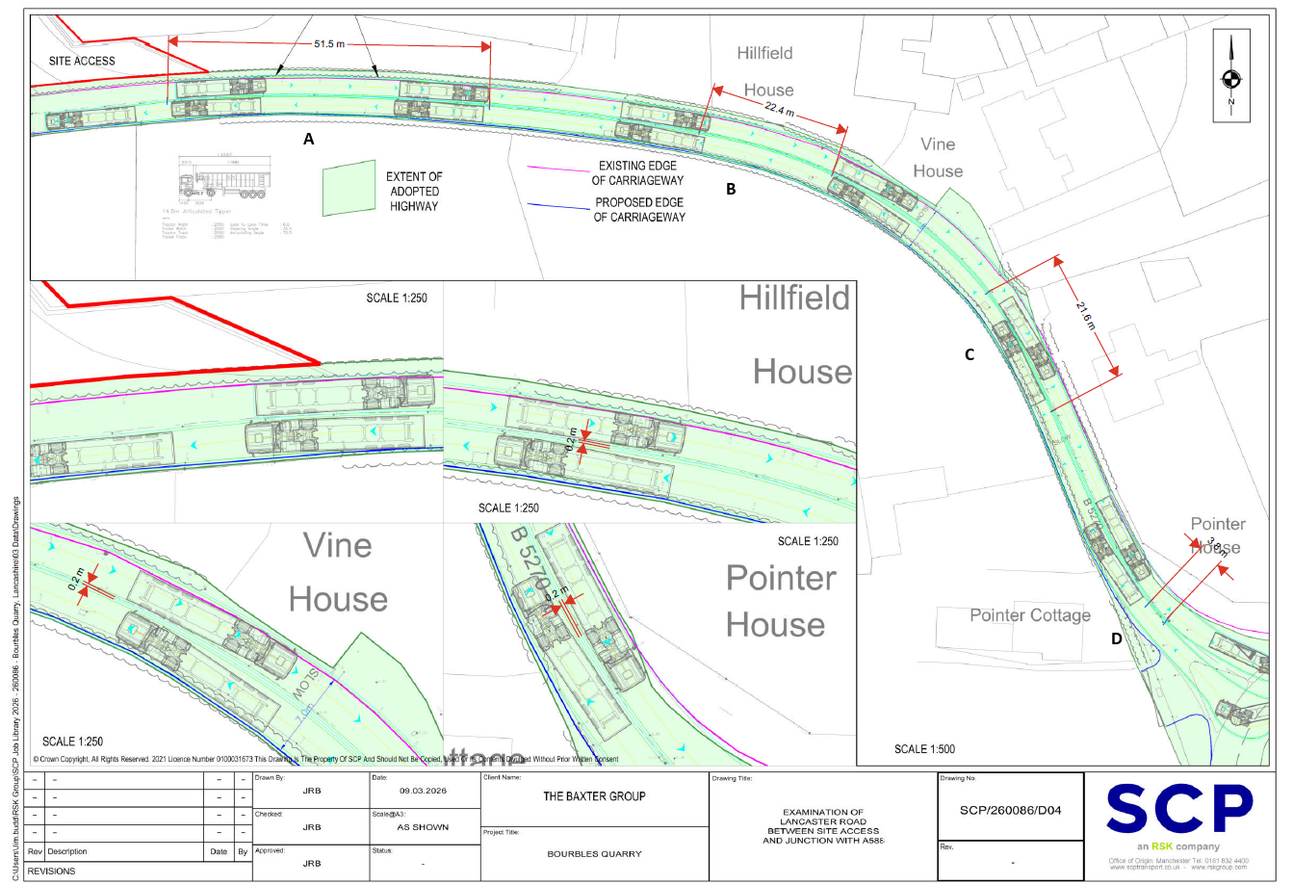

I am advised that the leading case is a CA case in which the relevant principles were reviewed: Hale v Norfolk CC CA (2001) Ch.

