Job Description

Directorate: | Education and Children Services
Service: | School Place Planning
Location: | County Hall/Hybrid
Salary range: | £53,051- £57,447 | Grade: | 11
Reports to: | School Planning Manager | Staff responsible for: | Up to 2

Job purpose and scope
To lead on the oversight, review, and implementation of the council's strategic approach to deliver and sustain sufficient school places for children and young people with SEND across Lancashire to ensure the council meets its statutory duties under the Children's and Families Act 2014 and assist in identifying proposals for the development of school places for pupils with SEND and the future use of school premises in adherence to the SEND White Paper and the governments wider Estates Strategy.

Performance Indicators
- Meeting statutory duties to keep SEND provision under review
- Robust forecast projections including statutory returns, such as SCAP
- Reduction of the number of INMSS places
- Increase in the number of commissioned specialist places
- Increase in the number of mainstream schools offering SEND provision
- Reduction in home-to-school travel costs for pupils with SEND
- Response to customer and client feedback
- Adherence to Leading Lancashire Framework

Leading Lancashire – Our Leadership Framework
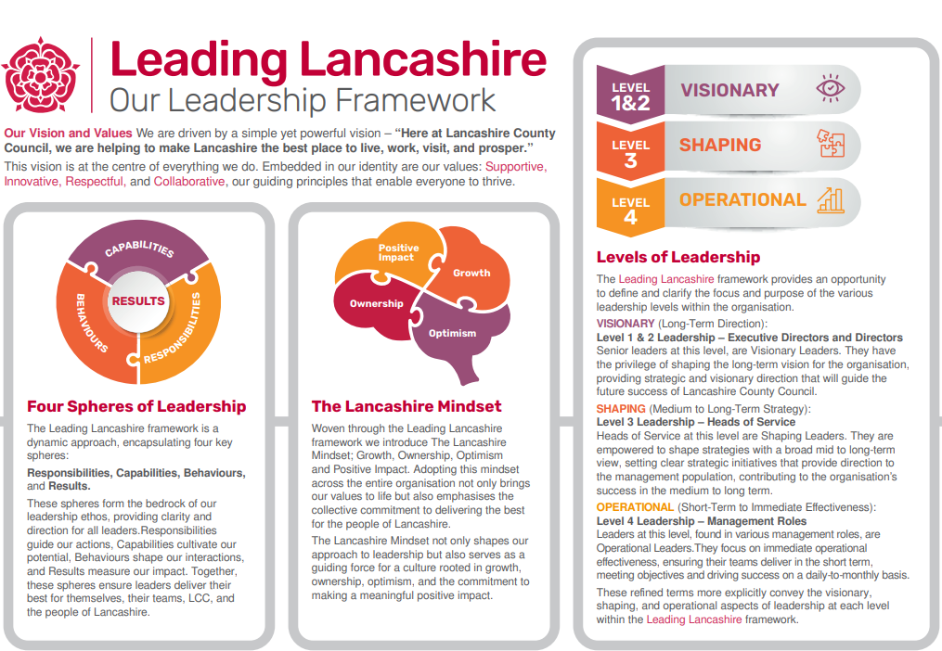

Accountabilities/Responsibilities
To work as part of the senior school place planning management team, undertaking a lead for
countywide SEND Sufficiency, identifying, and responding to traits, trends and risks of any influential factors that may prohibit children with SEND from gaining a place at an appropriate school, based on available forecast projection data and known housing growth in the district areas, reporting to the School Place Planning Manager and key stakeholders.

To contribute a SEND perspective to the council's response for Local Plan representation, providing a summary review and analysis for the school planning manager to feed into the central council planning team to enable cross directorate collaboration and a single council response to local district infrastructure needs. Where required prepare documentation to support Local Plan examination.

To develop a council wide approach to the collection of developer contributions for SEND specific provision and ensure that this is reflected in the councils Housing Methodology.

To provide reports, on request by the school place planning manager, to summarise analysis of SEND sufficiency and where appropriate provide periodic briefing papers, cabinet reports, Justification of Need (JON) papers and general responses to any queries raised, including but not limited to emails, letters of enquiries, consultations and or Freedom of Information (FOI) requests.

To recommend solutions to the school place planning manager to mitigate the impact of surplus provision in the mainstream estate working in collaboration with School Place Planning Sufficiency Principals to identify appropriate sites for SEND provision.

To ensure oversight on the SEND Capital Plan working closely with the Education Capital Team and SEND Statutory Team to consider present and future SEND sufficiency ensuring value for money in line with council policy and relevant Building Regulation Frameworks/Guidance.

To commission additional school places, in line with the SEND Strategy, through enlargement of existing provision, development of specialist bases in mainstream and or delivery of new schools ensuring adherence to the most up to date legislation and Department of Education (DfE) guidance.

To work in partnership and effectively communicate with all stakeholders, including senior managers, schools, diocese, academy trusts, elected members, and communities to provide technical data driven advice and guidance to support schools to plan and strategise their current and future operational needs in line with known demand.

To undertake an annual review in the Spring term of the SEND Sufficiency analysis, alongside peers, to assess future need and to provide a Justification of Need (JON) report to the school place planning manager where there is sufficient sustained need to bring forward new SDEND provision and thereafter to use this information to support commentary for the annual Statutory Capacity Assessment Programme (SCAP).

To contribute SEND knowledge and expertise through the attendance of district meetings with schools, planners and local elected members as well as through internal cross departmental/directorate meetings.

To manage the distribution of work priorities and the wellbeing of the School Place Planning SEND Sufficiency Officer/s.

Other
- Equal Opportunities
We are committed to achieving equal opportunities in the way we deliver services to the community and in our employment arrangements. We expect all employees to understand and promote this policy in their work.

- Health and safety
All employees have a responsibility for their own health and safety and that of others when carrying out their duties and must help us to apply our general statement of health and safety policy.

- Customer Focused
We put our customers' needs and expectations at the heart of all that we do. We expect our employees to have a full understanding of those needs and expectations so that we can provide high quality, appropriate services at all times.

- Safeguarding Commitment
We are committed to protecting and promoting the welfare of children, young people and vulnerable adults.

- Skills Pledge
We are committed to developing the skills of our workforce. All employees will be supported to work towards a level 2 qualification in literacy and numeracy if they do not have one already.

Our Values
We expect all our employees to demonstrate and promote our values:

- Supportive
We are supportive of our customers and colleagues, recognising their contributions and making the best of their strengths to enable our communities to flourish.

- Innovative
We deliver the best services we possibly can, always looking for creative ways to do things better, putting the customer at the heart of our thinking, and being ambitious and focused on how we can deliver the best services now and in the future.

- Respectful
We treat colleagues, customers and partners with respect, listening to their views, empathising and valuing their diverse needs and perspectives, to be fair, open and honest in all that we do.

- Collaborative
We listen to, engage with, learn from and work with colleagues, partners and customers to help achieve the best outcomes for everyone.

Person Specification

All the following requirements are essential unless otherwise indicated by *

Your ability to meet the job requirements will initially be assessed by the information provided on your application but further assessment will be undertaken at interview and, in some cases, by using other types of assessment(s).

Qualifications
- Degree in a relevant subject and or demonstrable experience within SEND education and or community governance.

- Management or project management qualification * (desirable)
Experience
- Significant experience of working to regulatory guidance, including awareness of SEND, ideally with a school organisation and or community governance bias.

- Demonstrable experience in project management, including managing programmes of work with competing priorities.

- Staff management, including experience of coaching and mentoring staff.

- Ability to interpret and analyse statistical data, seeking solutions to complex problems and present information in a clear and concise manner to a variety of audiences.

- Aptitude to write detailed, political sensitive reports for senior officers and elected members.

- Working in collaboration with a range of stakeholders to achieve a shared objective.

Essential knowledge, skills & abilities
- Demonstrable knowledge of SEND legislation and statutory guidance, including the Children and Families Act 2014 and the SEND Code of Practice (0–25).

- Excellent interpersonal skills with an ability to work with senior officers, local members and key school organisation partners to maintain effective working relationships.

- Ability to lead and motivate staff to produce high quality, accurate work to pressing deadlines.

- Proficient in the use of Excel / Word and a high skill level on computers

- Ability to work effectively as part of a team

- Good organisational skills and excellent attention to detail

- Ability to work under pressure, prioritise work and meet deadlines
- Excellent interpersonal and communication skills

- Ability to use own initiative and work autonomously to produce quality work
Other essential requirements
- Commitment to equality and diversity.
- Commitment to health and safety.
- Display the LCC values and behaviours at all times and actively promote them in others.
- This is an essential car user post
You will be required to provide a car for use in connection with the duties of this post and must be insured for business use. In certain circumstances consideration may be given to applicants who, as a consequence of a disability, are unable to drive

