Job Description

Directorate: | Education and Childrens Services
Service: | School Place Planning Principal- Housing
Location: | County Hall/Hybrid
Salary range: | £51,356- £55,612 | Grade: | 11
Reports to: | School Planning Manager | Staff responsible for: | 1

Job purpose and scope
A very experienced and professionally competent manager to lead on the strategic management of the council's countywide developer education contribution programme. With responsibility for service delivery across several service areas at a corporate level, providing professional expertise and advice to stakeholders /service users and contributing at a senior management level in a complex specialist area. Accountable for the quality and professionalism of others.

Performance Indicators
- Strong knowledge and understanding of Planning legislation.
- Ability to work in a political environment whilst developing and maintaining relationships and networks across districts and with competing objectives.
- Quality of advice/service against legal, safety and best practice standards.
- Achievement of relevant service targets and statutory responsibilities.
- Accountability for financial management ensuring all financial processes are compliant with organisational policies, audit requirements and funding conditions.
- Adherence to internal/external quality standards (if applicable).
- Adherence to policies and procedures.
- Accuracy and timeliness of information recording and processing.
- Customer and stakeholder feedback.
- Leading Lancashire Framework.

Leading Lancashire – Our Leadership Framework
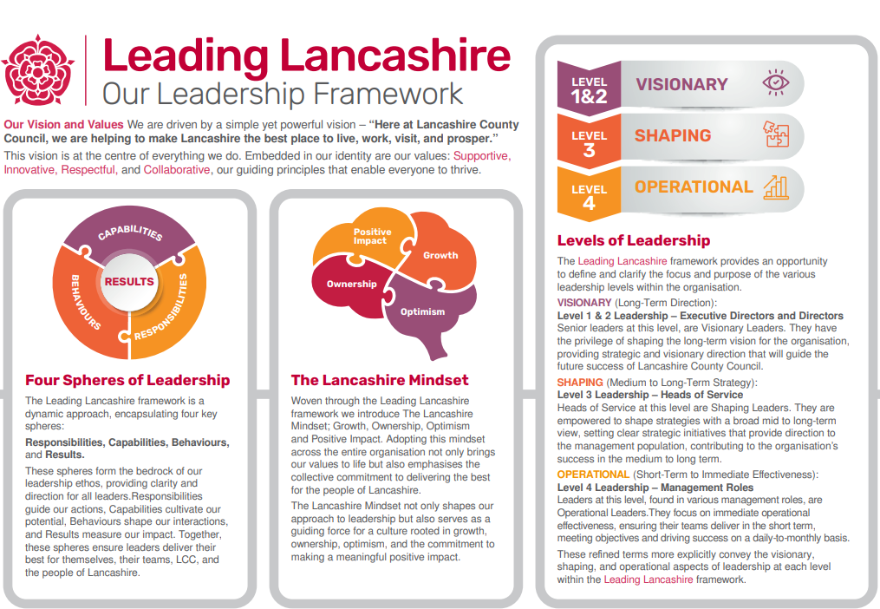

Accountabilities/Responsibilities
- Lead delivery of the council's developer education contribution programme to maximise
developer contributions to ensure there are sufficient school places to mitigate the impact of new housing development.
- Lead on long-term analysis of school place requirements including engagement in development of Local Plans.
- Translate broadly defined deliverables into a clear work schedule to align with the annual service plan for the team.
- Hold oversight in the co-ordination and integration of a range of work streams to provide clear objectives for the team.
- Lead the delivery of the team’s service objectives through project, legal and financial management (Infrastructure Funding Statement), to include commissioning site feasibility assessments, Section 106 agreements and oversight of Community Infrastructure Levy contributions.
- Respond to organisation and legislative changes that will impact on service delivery and be involved in critical elements of wider service planning across the authority.
- Leadership of management information systems to ensure they continue to be robust and fit for purpose.
- Develop an overview of the services to identify opportunities for efficiency and continuous operational improvement. May need to work beyond the service's boundaries and may deploy technical or commercial expertise to identify and deliver these improvements.
- Develop, manage and motivate a team which aspires to high standards of work and behaviour, by providing ongoing coaching and training.
- Review and prioritise the use of resources, to ensure they are put to best use in delivering the service.
- Build and develop partnerships and relationships with members, senior managers, external organisations and the community to ensure service priorities are shared and communicated effectively.
- Representation at formal planning hearings, where necessary, working with appointed legal representatives.

Other
- Equal Opportunities
We are committed to achieving equal opportunities in the way we deliver services to the community and in our employment arrangements. We expect all employees to understand and promote this policy in their work.

- Health and safety
All employees have a responsibility for their own health and safety and that of others when carrying out their duties and must help us to apply our general statement of health and safety policy.

- Customer Focused
We put our customers' needs and expectations at the heart of all that we do. We expect our employees to have a full understanding of those needs and expectations so that we can provide high quality, appropriate services at all times.

- Safeguarding Commitment
We are committed to protecting and promoting the welfare of children, young people and vulnerable adults.

- Skills Pledge
We are committed to developing the skills of our workforce. All employees will be supported to work towards a level 2 qualification in literacy and numeracy if they do not have one already.

Our Values
We expect all our employees to demonstrate and promote our values:

- Supportive
We are supportive of our customers and colleagues, recognising their contributions and making the best of their strengths to enable our communities to flourish.

- Innovative
We deliver the best services we possibly can, always looking for creative ways to do things better, putting the customer at the heart of our thinking, and being ambitious and focused on how we can deliver the best services now and in the future.

- Respectful
We treat colleagues, customers and partners with respect, listening to their views, empathising and valuing their diverse needs and perspectives, to be fair, open and honest in all that we do.

- Collaborative
We listen to, engage with, learn from and work with colleagues, partners and customers to help achieve the best outcomes for everyone.

Person Specification

All the following requirements are essential unless otherwise indicated by *

Your ability to meet the job requirements will initially be assessed by the information provided on your application but further assessment will be undertaken at interview and, in some cases, by using other types of assessment(s).

Qualifications
- Degree in a relevant subject and or extensive experience in a planning and or education organisation.
- Planning or Management qualification (* desirable)
Experience
- Demonstrable experience functioning at a strategic level, ideally operating with an education school organisation and or planning environment.
- Operating at a senior level with understanding standing of Directorate and Service area objectives.
- Ability to demonstrate strong analytical skills in resolving complex issues and managing conflicting priorities.
- Experience of communicating with a wider range of stakeholder and applying negotiation skills.
- Experience of developing and implementing policies responding to key changes in guidance and legislative.
Experience of providing in depth coaching and mentoring to develop others.

Essential knowledge, skills & abilities
- People management, and ability to coach, mentor and motivate a team.
- Project and change management skills.
- Strong analytical skills.
- Negotiation skills.
- Ability to build and maintain effective networks and relationships.
- Understanding of Directorate and Service area objectives, plus broad understanding of Council Community Strategy and Corporate Plan.
- In addition to the skills knowledge and experience described above, you may be required to undertake lower graded duties, as appropriate.
Other essential requirements
- Commitment to equality and diversity.
- Commitment to health and safety.
- Display the LCC values and behaviours at all times and actively promote them in others.
- This is an essential car user post
You will be required to provide a car for use in connection with the duties of this post and must be insured for business use. In certain circumstances consideration may be given to applicants who, as a consequence of a disability, are unable to drive

