In this unit:

This unit is all about climate change and sustainability. Children will be learning all about some simple changes that they can make to live more sustainably and have a positive impact on climate change and their world in the future.
Learning for life curriculum
Unit Title: Sustainability and Climate Change

The Learning for Life lesson packs have been designed to support schools in addressing pertinent and current issues in a creative and memorable way. They bring together a unique hybrid opportunity to use the recommended 60 active minutes to educate young people and prepare them for life in Modern Britain. Covering statutory RHSE objectives and considering wider personal development learning in this way not only allows teachers to cohesively weave in P.E opportunities to enhance their curriculum offer.
When delivering lessons, it is recommended that teachers are familiar with the PSHE Association best practice principles for delivery and maintain a safe learning environment for pupils in the same way that they would any other PSHE lesson. We recommend that teachers familiarise themselves with these using the interactive posters available here to support their professional development. It is also important to consider how to manage complex questions should they arise and support on this can be found here.
Similarly, we recommend that these lessons are delivered within curriculum time by the class teacher and appropriate risk assessments are carried out (where necessary) for your area, school and class. Lessons are a hybrid PE and PSHE lesson and therefore are required to be delivered by a confident member of teaching staff as per the PE recommendations to ensure the safety of all.
Finally, although on each lesson plan potential triggers for pupils are highlighted, this is not an exhaustive list. Please be careful when delivering lessons to be mindful of the needs of the class just as you would for any lesson.
If you have any thoughts on topics that you feel would be pertinent for us to begin developing, you can email your thoughts to: psheteam@lancashire.gov.uk where you can include the topics and the year groups you feel could benefit from a bespoke pack of work.

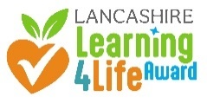
These units of learning have been designed to align with and support evidence towards the Lancashire Learning for Life Award which is available to any school to gain recognition for the opportunities they offer for personal development in school. More on the award can be found on the Lancashire Professional Development Service website.

Additionally, these units are also hosted as a collection on the PE passport app which is a whole school PE scheme designed to support teachers nationally in the delivery of Primary PE. If you would like to find out more, you can access information here:

SESSION 1
Pollution

Lesson Overview:  Pollution - Plastic | Lesson Objectives:  - To understand the key vocabulary linked to waste.  - To understand the waste hierarchy pyramid and be able to sort into an order articulating which are better/ worse for the environment.  - To work as team to come to a group decision. | Lesson Equipment:  - Whiteboards  - Cones  - Post it notes/ working wall  - Online workbook | RHSE Statutory Links:  Pupils should learn:  - The benefits of physical exercise, time outdoors, community participation, voluntary and service-based activity on mental wellbeing and happiness.  - The importance of respecting others, even when they have different preferences or beliefs.  - The conventions of courtesy and manners.

Key Vocabulary:  Sustainability  Carbon footprint  The waste hierarchy  Recycle  Reuse  Reduce  Repair/Recover  Dispose  Plastics | Potential triggers:  Consider children who may be experiencing some 'eco-anxiety' who may worry beyond the end of the lesson.  Research has shown that lots of children are worried about the Earth and the impact that climate change is negatively impacting their world.  They are worried about the impact that this is having on animals and the weather and what this means for their futures.  It is important to remind children that steps are being taken to make changes and that they can be a positive force for change and impact their future too. | Further Signposting for Staff:  Everyday Ways to Save Our Planet  (Laura Tobin)- this book has been used in the creation of this planning and provides practical ways to live sustainably.  How to teach children about climate change – BBC Teach  Teaching children about climate change- young people's views | Further signposting for pupils:  Everyday Ways to Save Our Planet  (Laura Tobin)- this book has been used in the creation of this planning and provides practical ways to live sustainably.  The Regenerators: What is the problem with plastic? - BBC Teach  Explore weather and climate - BBC Bitesize

SESSION 1: POLLUTION
 | Teaching Points | Opportunities for adaptation/extension
Task 1- Initial check-in /pre-assessment | Children will discuss the vocabulary in the booklet as well a  s complete the mind map about what they already know about sustainability and climate change.  Discuss in small groups and as a class.  Children will then complete the confidence bar at the bottom of session 1 to indicate how confident they feel they are with the current knowledge of sustainability and climate change. | Have a class discussion/ develop a working wall which indicates what children would like to find out more about.  Remind the children about the ask-it baskets/worry boxes that they could use to put in questions or concerns that they don't want to share more widely with the group to be addressed later.
Task 2- Fact or Fake News | Indicate one side of the room for Fact News and the opposite side of the room for Fake News.  Share the myth-busting fact slides about plastics with the children and ask them to move to the side of the room they think is the correct answer. | Use STEP for adaptation (see above).
Task 3- The Waste Hierarchy Pyramid | Share the words on the ppt from the pyramid and children work in groups- each write one word on a whiteboard and discuss definition and meaning. | Consider making/writing an individual or class pledge which will support change.
Task 3 – Practical | Go outdoors and set up practical activity (see PowerPoint)  Children then discuss in their groups and order the 5 whiteboards vertically into their own pyramid in order of importance whilst completing practical activity; 1 – Best environmental impact, 5 – worst for the environment. | Increase/ decrease distance between cones.  Take photographs of the children's finished order for working wall/ plenary.
Task 3 – The Waste Hierarchy Pyramid Recap | Show the children the hierarchy pyramid slide, discuss the infographic of the pyramid. Does it match theirs? What differences are there? Why have the chosen to put things where they have?  What links can they make from their homes/lives to the pyramid? Are there any practical changes they could make in their every day lives to support this?
Task 4 – Plenary - Our Pollution Pledges | As a class discuss what sustainable small changes can everyone make that would impact their reduction in waste? This can be completed in workbook, on post its and added to the working wall.  Complete the reflection section in the workbook. | Reflection section could be completed as a morning task the following day.  This activity could be taken into English lessons and children could create an information text/poster, write a letter to planet earth, write a persuasive argument to council/ headteacher etc.  The children could create and lead an assembly on small changes to the rest of the school.

SESSION 2
Active Travel

Lesson Overview:  Pollution – Active Travel | Lesson Objectives:  - To understand what active travel is.  - To understand the benefits of active travel.  - To understand the importance of active travel to individuals and families, schools, communities and the planet.  - To work as team to come to a group decision. | Lesson Equipment:  - Whiteboards  - Cones  - Post it notes/ working wall  - Online workbook | RHSE Statutory Links:  - The benefits of physical exercise, time outdoors, community participation, voluntary and service-based activity on mental wellbeing and happiness.  - The importance of respecting others, even when they have different preferences or beliefs.  - The conventions of courtesy and manners.

Key Vocabulary:  Sustainability  Carbon footprint  The waste hierarchy  Recycle  Reuse  Reduce  Repair/Recover  Dispose  Plastics | Potential triggers:  Consider children who may be experiencing some 'eco-anxiety' who may worry beyond the end of the lesson.  Research has shown that lots of children are worried about the Earth and the impact that climate change is negatively impacting their world.  They are worried about the impact that this is having on animals and the weather and what this means for their futures.  It is important to remind children that steps are being taken to make changes and that they can be a positive force for change and impact their future too. | Further Signposting for Staff:  Everyday Ways to Save Our Planet  (Laura Tobin)- this book has been used in the creation of this planning and provides practical ways to live sustainably.  How to teach children about climate change – BBC Teach  Teaching children about climate change- young people's views | Further signposting for pupils:  Everyday Ways to Save Our Planet  (Laura Tobin)- this book has been used in the creation of this planning and provides practical ways to live sustainably.  The Regenerators: What is the problem with plastic? - BBC Teach  Explore weather and climate - BBC Bitesize

SESSION 1: POLLUTION
 | Teaching Points | Opportunities for adaptation/extension
Task 1- Initial check-in /pre-assessment | Discuss where the children travel to regularly, how do they get there and do they know how many miles it is?  How many cars do they have at their home? Fill in work with ideas.  How do they travel to and from school?  Ask children open ended question: What is Active Travel? What do you think it could be? Is getting a bus active travel?  Create a bar chart using (PowerPoint slides) to work out how the class travelled to school. Children then repeat activity asking which way children would like to travel to school. What is the difference of how children would like to travel to school?  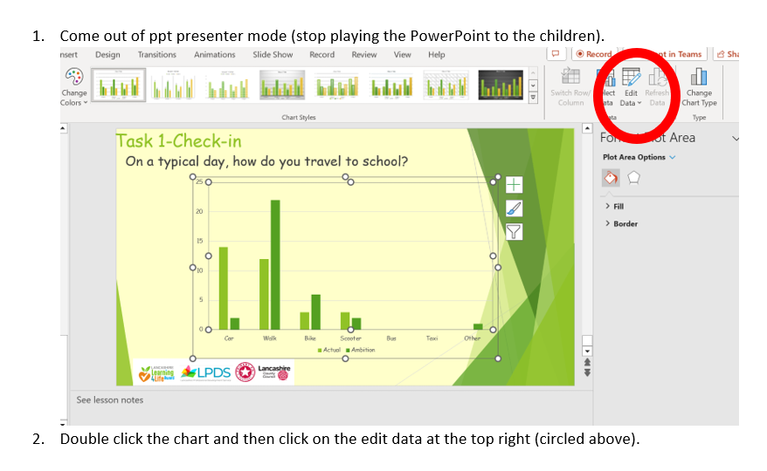  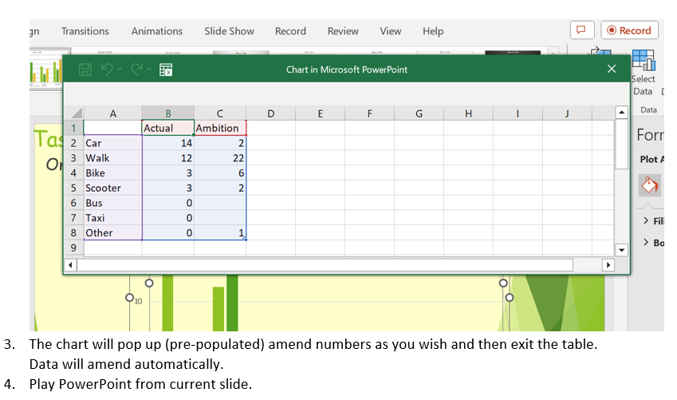 | To work out percentages and create Pie chart.  To use chart already set up to support
Task 2- Why is active travel important? | Discuss that transport accounts for 27% of the UK's total emissions – making it the most polluting sector!  Discuss with the children what is active travel? Share definition  The average distance travelled to school is 2.5 miles (1.6 miles for Primary, 3.4 for secondary) – a 40 minute walk.  It takes 25-30 minutes to walk 1.6 miles 3,100 steps of daily 10,000  Bikes, walking  Food transportation
Task 3 – What are the benefits of active travel? | Discuss the benefits of active travel.  Then discuss how active travel benefits individuals, families, communities and the planet. Children to have whiteboards with the headings on and a group discussion trying to think of benefits.  Keep this as an active round robin (children standing, contributing to one table and then moving to the next after a short time).  Share ideas and the slide with more answers on, what are the things you did/did not consider?
Task 3 – Obstacle course Alley | Children to think about their route to school and the obstacles they may face on the way. Think about anything that may need to consider and make a list of it in a flow chart plotting out their trip.  Main road cross under the bypass across the zebra crossing over the traffic lights cross at the crossing patrol down the alley into playground etc…  Then group the children into 3's and share their journeys with one another and look for the most common obstacles and the most interesting obstacles.  From there, create an obstacle course flowchart on a whiteboard which has obstacles that they can set up to create their own obstacle course.  Write this out to take outside.
Task 3 – | Create the obstacle course outside and practise this and adapt.  Complete the obstacle course without any distractions and the team who have made it to explain what they need to do.  Then consider pairing up and explain how to do it blindfolded/impaired visually with DIY goggles/reading a book aloud/carrying an egg and spoon.  This will simulate not being fully aware of senses. Liken this to being distracted on phones etc… and not paying attention when out and about.

SESSION 3
Healthy Food Choices

Lesson Overview:  Pollution | Lesson Objectives:  - To understand the impact that food waster has on our carbon footprint.  - To present information in a clear and coherent way about the impact of food choices on our planet.  - To work as team to collect the most objects | Lesson Equipment:  - Whiteboards  - Cones  - A range of small, medium and large PE equipment  - Online workbook | RHSE Statutory Links:  - The benefits of physical exercise, time outdoors, community participation, voluntary and service-based activity on mental wellbeing and happiness.  - The importance of respecting others, even when they have different preferences or beliefs.  - The conventions of courtesy and manners.

Key Vocabulary:  Sustainability  Carbon footprint  The waste hierarchy  Recycle  Reuse  Reduce  Repair/Recover  Dispose  Plastics | Potential triggers:  Consider children who may be experiencing some 'eco-anxiety' who may worry beyond the end of the lesson.  Research has shown that lots of children are worried about the Earth and the impact that climate change is negatively impacting their world.  They are worried about the impact that this is having on animals and the weather and what this means for their futures.  It is important to remind children that steps are being taken to make changes and that they can be a positive force for change and impact their future too. | Further Signposting for Staff:  Everyday Ways to Save Our Planet  (Laura Tobin)- this book has been used in the creation of this planning and provides practical ways to live sustainably.  Resources | The World's Largest Lesson (globalgoals.org) Heroes for Change and one page goals Comics  How to teach children about climate change – BBC Teach  Teaching children about climate change- young people's views | Further signposting for pupils:  Everyday Ways to Save Our Planet  (Laura Tobin)- this book has been used in the creation of this planning and provides practical ways to live sustainably.  The Regenerators: What is the problem with plastic? - BBC Teach  Explore weather and climate - BBC Bitesize

SESSION 3: HEALTHY FOOD CHOICES
 | Teaching Points | Opportunities for adaptation/extension
Task 1- Initial check-in /pre-assessment | Everything we eat has an impact on the planet.  Discuss with the children what they think this means and why?  Just like the energy used to heat our homes, the food we fuel our bodies with has a significant carbon footprint. Food pollution – that's everything from the land, water and resources used to grow our food to the way it is transported, packaged and disposed of accounts for a quarter of global greenhouse gases.  Look at the facts on the PowerPoint stand up or sit down  The choices we make about what we eat, the packaging that food comes in and how much we throw away have a huge impact on the environment.
Task 2- | Discuss food waste  UK households throw an average of six meals a week away – made up of peelings, scraps, food that’s gone past it's best, food we don't like and leftovers we don't want.  Food waste alone produces 8-10% of all global greenhouse gas emissions. Food in landfill releases harmful gas into the environment.  Look at the following article  Lancashire's waste recycling is set to be revolutionised | Lancashire County Council News  Children to discuss if they are in favour of food waste bins. | Children could write to Lancashire County Council councillors ahead of the new food waste scheme and offer to create posters/ flyers for the council to advertise the new food waste bin scheme.
Task 3- Practical | Go outside and set up game. Larger objects nearer to the children, smaller objects a longer distance away. In teams of 4/5 in a relay style, one child from each team runs to collect one item at a time and return to team and place in a hoop. Then next child goes. Children to collect as many items as possible in an allotted time. Most items win.  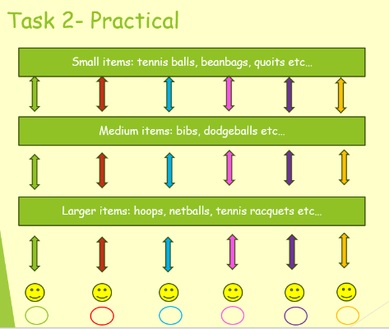  Explain after the activity that the learning to take from this task is that running further takes more energy – this is similar to food miles.  It is important to think about the impact on the environment and the amount of energy used up by importing foods from far away. It is important that we consider the economic implications of important but the impact it has on the environment is vast.  The practical activity was a way of demonstrating how much more energy is taken up by importing things from further afield.  The further the import, the more impact this has on the planet- this is to be likened to the activity- the further the distance the more work and strain it put onto your body.  The more mindful we can be about where we get things from, the better it is for the environment. Similarly, the important message is that often, the closer things are made to home, the seasonal items available to us are often of better quality, more organic and better for us than some of the items from further afield. This is because it will be taking less time to get from farm to fork meaning that there will be less need for preservatives and the food will be fresher.  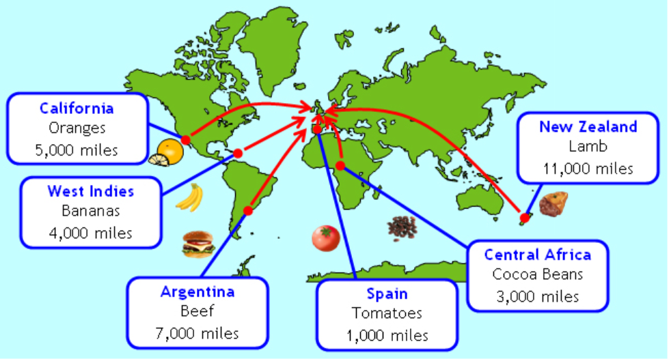 | Activity could be done outside or in a hall. Teacher to decide on distance between cones.
Task 4 – Research Project | Discuss that there are lots of steps that can be taken to make healthy food choices to help our planet.  Use the BBC bitesize website for further information  What is food sustainability and why is it important? - BBC Bitesize  Watch the first video and take notes about simple changed: saving food for snacks, reducing food waste, composting food, only buying what is needed and thinking about eating seasonal and local produce. Children to make notes.  They can then use the further information and the articles on the page to find out more and think about how they want to present their findings and how they can ‘spread the word’.  Children may decide they want to research their own food carbon footprint/create a podcast and record it with key information/ produce a newsletter item to be sent home/ create a news bulletin to film/ develop a poster or information leaflet for other people within school/ write a letter to the local council trying to persuade them to encourage food waste collection and the reasons and benefits for this.  They can then use the links to find out more information and create a project to promote positive change and share the facts they have learned.  Climate change food calculator: What's your diet's carbon footprint? - BBC News | Research information could be sent home to parents.  Children could discuss food choices with the school kitchen/ headteacher and governors.

