Job Description

Directorate: | Place
Service: | Environment
Location: | County-wide (office base: Cuerden Way, Bamber Bridge PR5 6BQ)
Salary range: | SCP30-35 | Grade: | 9
Reports to: | Principal Flood Risk Officer | Staff responsible for: | 3

Job purpose and scope
This role is in the Flood Risk Management Team, within the County Council's Environment and Regulatory Directorate. The team delivers the Lead Local Flood Authority functions, which include the council's duties under the Flood and Water Management Act 2010 and its powers under the Land Drainage Act 1991.
The post holder will have responsibility for supporting the delivery of policy and operational aspects of the Flood Risk Management Team, particularly in relation to statutory flood incident investigations, watercourse enforcement activities, and flood risk management projects. They will also have responsibilities for delivering objectives arising from the Local Flood Risk Management Strategy that are relevant to the team, and for supporting any other aspects of the delivery of the County Council's Flood Risk Management responsibilities within a team of flood risk professionals.
The successful candidate will be required to work closely with other Risk Management Authorities, with Local Planning Authorities, and with other partner organisations across multiple districts within Lancashire to understand flood risks and to identify and deliver ways to manage those risks as effectively and as efficiently as possible.
There will be a need to attend occasional evening appointments and community engagement events outside traditional working hours.

Performance Indicators
- Quality of advice/service against legal, safety and best practice standards
- Achievement of relevant service targets
- Adherence to internal/external quality standards if applicable
- Adherence to policies and procedures
- Accuracy and timeliness of information recording and processing
- Customer and stakeholder feedback
- Leading Lancashire Framework

Leading Lancashire – Our Leadership Framework
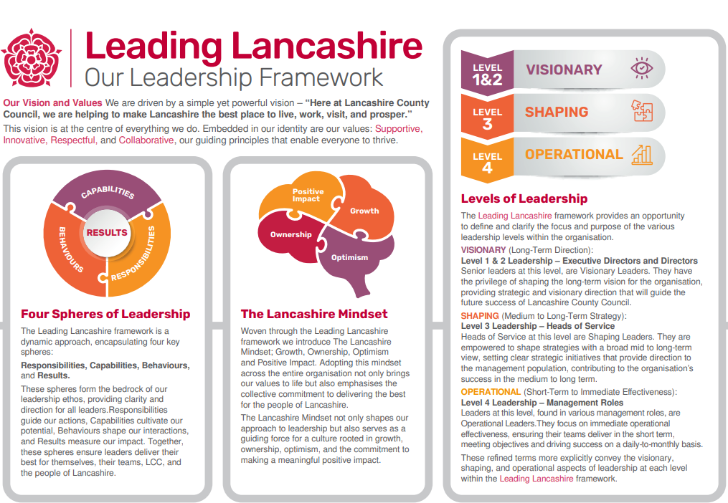

Accountabilities/Responsibilities
- Investigate reports of flooding received from residents, elected representatives and other affected parties, in accordance with current policies, using a combination of historical research, on-site investigations, data analysis, professional expertise, joint working with land owners, partner organisations, and other relevant techniques, subject to the circumstances of each flooding incident. Contribute technical knowledge and professional advice to statutory and other reports into the flooding incidents investigated.

- Identify the feasibility of potential projects (including studies and works) to reduce flood risk to affected communities and key infrastructure, including researching and appraising options, liaison with stakeholders, securing and managing various funding mechanisms including national grants and regional funding streams.

- Manage and deliver flood risk management works and other projects arising from this feasibility work, including those works and projects delivered by specialist consultants and suppliers.

- Develop and maintain effective relationships and communications with other agencies and service providers, to share information and to ensure joined-up service provision.

- Provide support to the council's Principal Flood Risk Officers on complex drainage management issues and their associated legal and financial risks as required.

- Provide appropriate specialist advice and guidance in response to service enquiries and requests, including those from Councillors, MPs senior internal colleagues and partner organisations.

- Provide day-to-day management, technical guidance and specialist training to team members to ensure they remain equipped to deliver their responsibilities and to maintain industry-standard knowledge and experience (example topics include site health and safety, water quality, sustainable water management techniques, ecology, conservation, national flood risk funding opportunities).

- Identify and implement opportunities for improvements to policy and procedures within the work area to improve professional practice and customer satisfaction and develop policy/procedural improvements in line with the service commitment to delivering the Local Flood Risk Management Strategy.

Other
- Equal Opportunities
We are committed to achieving equal opportunities in the way we deliver services to the community and in our employment arrangements. We expect all employees to understand and promote this policy in their work.

- Health and safety
All employees have a responsibility for their own health and safety and that of others when carrying out their duties and must help us to apply our general statement of health and safety policy.

- Customer Focused
We put our customers' needs and expectations at the heart of all that we do. We expect our employees to have a full understanding of those needs and expectations so that we can provide high quality, appropriate services at all times.

- Safeguarding Commitment
We are committed to protecting and promoting the welfare of children, young people and vulnerable adults.

- Skills Pledge
We are committed to developing the skills of our workforce. All employees will be supported to work towards a level 2 qualification in literacy and numeracy if they do not have one already.

Our Values
We expect all our employees to demonstrate and promote our values:

- Supportive
We are supportive of our customers and colleagues, recognising their contributions and making the best of their strengths to enable our communities to flourish.

- Innovative
We deliver the best services we possibly can, always looking for creative ways to do things better, putting the customer at the heart of our thinking, and being ambitious and focused on how we can deliver the best services now and in the future.

- Respectful
We treat colleagues, customers and partners with respect, listening to their views, empathising and valuing their diverse needs and perspectives, to be fair, open and honest in all that we do.

- Collaborative
We listen to, engage with, learn from and work with colleagues, partners and customers to help achieve the best outcomes for everyone.

Person Specification

All the following requirements are essential unless otherwise indicated by *

Your ability to meet the job requirements will initially be assessed by the information provided on your application but further assessment will be undertaken at interview and, in some cases, by using other types of assessment(s).

Qualifications
- Degree qualified (or equivalent) in relevant subject plus number of years' experience in a similar role OR significant relevant vocational experience, demonstrating technical and professional development through involvement in a series of progressively more demanding roles in associated topic areas
- Operational/Departmental management qualification or nationally-recognised Project Management Qualification*
- Professional qualification, membership of a professional body, or working towards such qualification*
Experience
- Experience of achieving mutually satisfactory outcomes for multiple parties engaged in a problem, including those parties with challenging circumstances and/or behaviours.
- Experience of supporting the development, implementation and monitoring of projects, policies and procedures.
- Experience of preparing technical reports and presenting complex information to a range of audiences.
- Experience of directing and managing the day-to-day activities of a small team of technical officers
- Experience of the development management and policy planning processes relevant to the Lead Local Flood Authority, and effective communication and building relationships with Local Planning Authorities and flood risk management authorities. *
- Experience working in a flood and coastal risk management or related policy environment.*

Essential knowledge, skills & abilities
  - Up-to-date and thorough knowledge and understanding of the work practices, systems, processes, policies and procedures relevant to this role or to equivalent roles in other similar technical services, and a good understanding of flood risk management governance related to the lead local flood authority role.
  - Clear and robust understanding of the roles and responsibilities of flood risk management authorities, local planning authorities and other key partners in delivering flood risk management, or their equivalents in similar technical services.
  - Detailed understanding of the professional, regulatory, statutory and corporate frameworks/standards relevant to the role, or their equivalents in similar technical services.
  - Sound analytical and problem solving capability.
  - Able to monitor, train and mentor other professional staff.
  - Able to influence others’ behaviour through effective relationship building.
  - Ability to manage your own time, workload and priorities and those of your staff members to meet targets and deliver successful outcomes during periods of variable workload and demands.

Other essential requirements
- Commitment to equality and diversity.
- Commitment to health and safety.
- Display the LCC values and behaviours at all times and actively promote them in others.
- This is an essential car user post
You will be required to provide a car for use in connection with the duties of this post and must be insured for business use. In certain circumstances consideration may be given to applicants who, as a consequence of a disability, are unable to drive

