Job Description

Directorate: | Resources
Service: | Legal Services
Location: | County Hall, Preston
Salary range: | £55,612 to £60,147 | Grade: | 12
Reports to: | Strategic Legal Manager | Staff responsible for:

Job purpose and scope
One of the Council's senior legal professionals within Legal Services, providing expert legal advice and representation across Employment law matters. The post holder will be heavily involved and integrated within service areas, advising, influencing, shaping and challenging at senior levels to support the delivery of strategic priorities, workforce projects and statutory functions.

The post holder will possess a high level of professional expertise and experience across Employment law, including Employment Tribunal litigation, workforce reorganisation, TUPE, equality law, industrial relations and public sector employment issues. They will also possess an understanding of public law and governance principles relevant to local authority decision-making.

The post holder will exercise a significant degree of professional independence and discretion, leading on highly complex, innovative, sensitive and high-profile matters. They will be recognised as a specialist legal adviser and will provide technical leadership, support and mentoring to colleagues across Legal Services.

Working closely with the Strategic Legal Manager and Principal Employment Lawyer, the post holder will support corporate priorities, transformation projects, workforce initiatives, service development and effective risk management, ensuring lawful and robust decision-making throughout the Council.

Performance Indicators
- Quality of legal advice and service against legal, professional and best practice standards.
- Achievement of relevant service objectives and targets.
- Adherence to internal and external professional standards.
- Effective management of complex and high-risk litigation.
- Positive customer and stakeholder feedback.
- Delivery of service improvements and strategic objectives.
- Effective leadership and development of team members.
- Demonstration of the Lancashire Leadership Framework.

Leading Lancashire – Our Leadership Framework
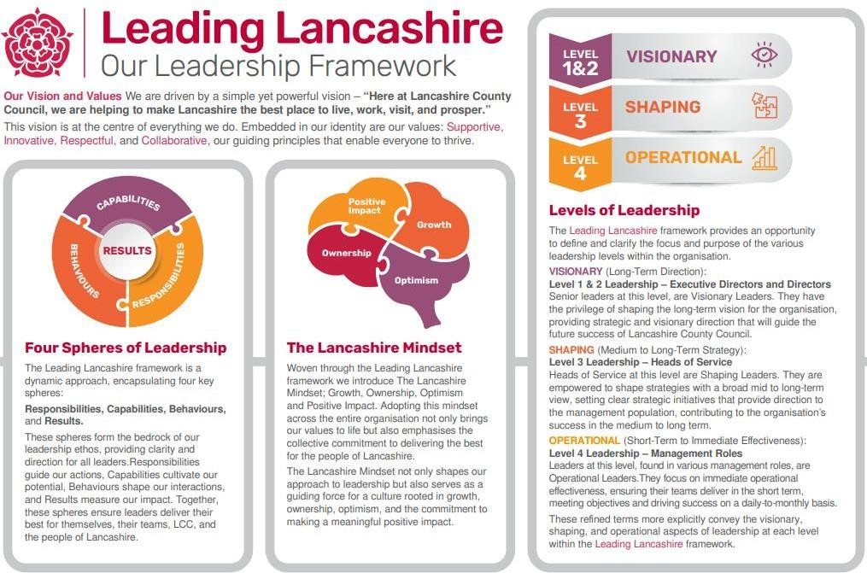

Accountabilities/Responsibilities
- Provide specialist legal advice across all aspects of employment and workforce law.
- Lead on complex, novel, sensitive and high-risk employment law matters affecting the Council.
- Act as lead legal adviser on significant workforce projects, organisational change programmes and service transformation initiatives.
- Advise Directors, Heads of Service, senior officers and elected members on employment law, legal risk, governance and decision-making.
- Provide advice on public law, equality duties, judicial review risk, statutory powers and duties, and lawful employment decision-making.
- Conduct and oversee Employment Tribunal litigation and other employment-related proceedings.
- Advise on major restructures, TUPE transfers, collective consultation exercises and strategic workforce matters.
- Support the Council's response to legislative reform, emerging case law developments and national workforce initiatives.
- Develop and deliver legal training to officers, managers and colleagues.
- Provide technical supervision, mentoring and support to lawyers and legal support staff.
- Develop productive relationships with HR, Trade Unions, ACAS, external advisers and partner organisations.
- Represent the Council in meetings, negotiations, working groups and professional forums.
- Contribute to the development of legal practice standards and continuous improvement initiatives.

Other
- Equal Opportunities
We are committed to achieving equal opportunities in the way we deliver services to the community and in our employment arrangements. We expect all employees to understand and promote this policy in their work.
- Health and safety
All employees have a responsibility for their own health and safety and that of others when carrying out their duties and must help us to apply our general statement of health and safety policy.
- Customer Focused
We put our customers' needs and expectations at the heart of all that we do. We expect our employees to have a full understanding of those needs and expectations so that we can provide high quality, appropriate services at all times.
- Safeguarding Commitment
We are committed to protecting and promoting the welfare of children, young people and vulnerable adults.

- Skills Pledge
We are committed to developing the skills of our workforce. All employees will be supported to work towards a level 2 qualification in literacy and numeracy if they do not have one already.

Our Values
We expect all our employees to demonstrate and promote our values:
- Supportive
We are supportive of our customers and colleagues, recognising their contributions and making the best of their strengths to enable our communities to flourish.

- Innovative
We deliver the best services we possibly can, always looking for creative ways to do things better, putting the customer at the heart of our thinking, and being ambitious and focused on how we can deliver the best services now and in the future.
- Respectful
We treat colleagues, customers and partners with respect, listening to their views, empathising and valuing their diverse needs and perspectives, to be fair, open and honest in all that we do.
- Collaborative
We listen to, engage with, learn from and work with colleagues, partners and customers to help achieve the best outcomes for everyone.

Person Specification
All the following requirements are essential unless otherwise indicated by *

Your ability to meet the job requirements will initially be assessed by the information provided on your application but further assessment will be undertaken at interview and, in some cases, by using other types of assessment(s).

Qualifications
- Honours Degree level qualification or equivalent experience
- Relevant professional qualification or equivalent
- Admitted Solicitor, Barrister, Chartered Legal Executive or equivalent with current practising certificate
Experience
- Significant post-qualification experience advising on Employment law matters.
- Experience of advising local authorities or public sector organisations on complex and sensitive employment issues.
- Experience of managing a substantial caseload of complex matters with minimal supervision.
- Experience of advising senior officers and elected members.
- Experience of supporting major projects, transformation programmes or workforce change initiatives.
- Experience of Employment Tribunal litigation and dispute resolution.
- Experience of advising on TUPE, collective consultation, restructuring, industrial relations and equality matters.
- Experience of partnership working with Trade Unions, ACAS, external legal advisers and key stakeholders.
- Experience of providing technical support, supervision or mentoring to legal colleagues.
- Experience of advising on public law and governance issues within a local authority environment.
Essential knowledge, skills & abilities

- Authoritative knowledge of Employment law and practice.
- Comprehensive understanding of employment litigation, Employment Tribunal procedure and dispute resolution.
- Extensive knowledge of workforce restructuring, TUPE, industrial relations, discrimination law and equality legislation.
- Comprehensive understanding of local government public law and governance.
- Extensive knowledge of judicial review principles and lawful decision-making.
- Ability to provide expert legal advice on complex, novel and high-risk matters.
- Ability to identify legal and organisational risks and develop practical solutions.
- Ability to influence senior decision-makers through clear, authoritative advice.
- Strong advocacy, negotiation and drafting skills.
- Ability to support and develop colleagues through coaching, mentoring and technical supervision.
- Ability to identify implications arising from legislative change, case law and government policy developments.
- Ability to manage competing priorities and deliver outcomes within tight timescales.
- Ability to communicate complex legal principles clearly to non-legal audiences.
- Strong commitment to continuous improvement and professional excellence.
- Advanced IT and case management skills.
Other essential requirements
- Commitment to equality and diversity.
- Commitment to health and safety.
- Display the LCC values and behaviours at all times and actively promote them in others.
- This is an essential car user post
You will be required to provide a car for use in connection with the duties of this post and must be insured for business use. In certain circumstances consideration may be given to applicants who, as a consequence of a disability, are unable to drive

