Job Description

Directorate: | Resources
Service: | Strategy and Innovation
Location: | County Hall, Preston
Salary range: | Grade 14 | Grade: | 14
Reports to: | Director – Strategy and Innovation | Staff responsible for: | 48

Job purpose and scope
The post holder will lead the planning and effecting the delivery of the council's Transformation and Improvement Portfolio, supporting the pollical leadership, Executive Leadership Team (ELT) and the Director of Strategy and Innovation.
- Delivering the ambition and vision for change with associated business cases, significant financial and non-financial benefits, programmes, change methodologies and resources.

- Inspiring and supporting senior managers across the council to achieve the Transformation and Improvement Portfolio outcomes.

- Ensuring that the complex programmes of service improvement required to achieve the council's ambitions are effectively co-ordinated, planned, delivered at pace.

- Ensuring programmes are embedded across the organisation, with demonstrable outcomes for stakeholders and customers.

- Lead the Transformation and Improvement Portfolio and management of interdependencies, including oversight of any risks.

- Horizon scanning to identify future change and transformation opportunities and to manage potential challenges and threats.

- Leading and developing the transformation and service improvement service, as a high-quality internal consultancy with a range of change capabilities

Performance Indicators
- Quality of advice/service against legal, safety and best practice standards
- Achievement of relevant service targets
- Adherence to internal/external quality standards if applicable
- Adherence to policies and procedures
- Accuracy and timeliness of information recording and processing
- Customer and stakeholder feedback
- Leading Lancashire Framework

Leading Lancashire – Our Leadership Framework
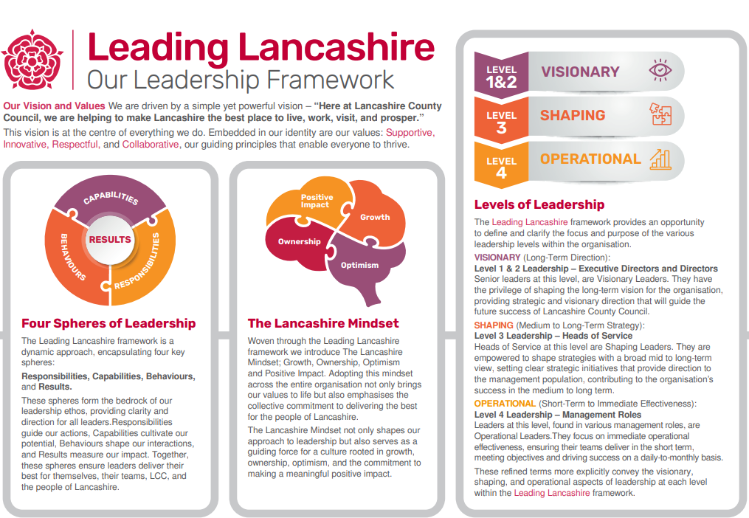

Accountabilities/Responsibilities
- Developing the Transformation and Improvement Portfolio based on the agreed change priorities and our corporate priorities, as well as the new and emerging organisational needs.

- Leading and developing the Transformation and Improvement Service, ensuring high performance and a strong internal consultancy offer to deliver the change portfolio.

- Developing the organisational skills, capacity and capabilities necessary to deliver the change portfolio including portfolio and programme management capability, business case development, and service redesign capabilities.

- Lead the design and development of effective business cases evidencing clear options appraisals and benefits aligned to customer, employee, and significant efficiencies.

- Nurture effective relationships with ELT and Senior Leadership Team (SLT) to develop and communicate the changes that are necessary to deliver the Transformation and
- Improvement portfolio helping them to understand and operationalise new ways of working in order to improve our employee and customer experience.

- Identify, adapt and adopt leading practice to ensure the key outcomes of the Transformation and Improvement portfolio are delivered.

- Working with SLT to ensure that new business change requirements and external factors influencing service development and delivery are identified, analysed, understood and reflected in the Transformation and Improvement portfolio where necessary.

- Interfacing closely with the Digital Strategy and Digital Services to ensure close alignment between the delivery of the digital programme and the change portfolio.

- Ensure excellent and robust governance arrangements across all transformation and improvement programmes and projects that support delivery of the change portfolio.

- Leading on the mitigation of all risks associated with transformational programmes and projects.
- Budget management of the change service and associated programmes of activity.

Other
- Equal Opportunities
We are committed to achieving equal opportunities in the way we deliver services to the community and in our employment arrangements. We expect all employees to understand and promote this policy in their work.

- Health and safety
All employees have a responsibility for their own health and safety and that of others when carrying out their duties and must help us to apply our general statement of health and safety policy.

- Customer Focused
We put our customers' needs and expectations at the heart of all that we do. We expect our employees to have a full understanding of those needs and expectations so that we can provide high quality, appropriate services at all times.

- Safeguarding Commitment
We are committed to protecting and promoting the welfare of children, young people and vulnerable adults.

- Skills Pledge
We are committed to developing the skills of our workforce. All employees will be supported to work towards a level 2 qualification in literacy and numeracy if they do not have one already.

Our Values
We expect all our employees to demonstrate and promote our values:

- Supportive
We are supportive of our customers and colleagues, recognising their contributions and making the best of their strengths to enable our communities to flourish.

- Innovative
We deliver the best services we possibly can, always looking for creative ways to do things better, putting the customer at the heart of our thinking, and being ambitious and focused on how we can deliver the best services now and in the future.

- Respectful
We treat colleagues, customers and partners with respect, listening to their views, empathising and valuing their diverse needs and perspectives, to be fair, open and honest in all that we do.

- Collaborative
We listen to, engage with, learn from and work with colleagues, partners and customers to help achieve the best outcomes for everyone.

Person Specification

All the following requirements are essential unless otherwise indicated by *

Your ability to meet the job requirements will initially be assessed by the information provided on your application but further assessment will be undertaken at interview and, in some cases, by using other types of assessment(s).

Qualifications
- Honours Degree level qualification or equivalent experience

- Relevant professional qualification or equivalent
Experience
- Significant professional and/or management experience of a strategic operation/service

- A demonstrative record of delivering high quality services against challenging objectives and resources.

- A demonstrative record of operational management of a major service spanning across a major arm of the organisation.

- Engaging, guiding and influencing senior managers within the area of responsibility.

- Experience of leading, inspiring and motivating teams to drive services forward, achieving high quality delivery within reducing resources.

- Experience of working across services outside of the area of responsibility to ensure delivery of corporate objectives.

Essential knowledge, skills & abilities
- Highly developed knowledge (broad and/or deep) of the principles, theory and practice of the specialist area of responsibility.

- Comprehensive understanding of the activities and objectives of the Council, both current and future.

- Ability to successfully influence key decision makers at senior levels, both internal and external to the Council.

- Effective Leadership and Management at a senior level of a diverse workforce to support excellence in service delivery.

- Good understanding of the political context at regional and local level and working with Elected Members in a constructive and sensitive way.

- Successful financial management including prioritisation within decreasing resources.

- Ability to lead, develop, manage and motivate services/teams in a challenging and changing environment.

- Ability to quickly build credibility with senior managers and stakeholders.

- Ability to embed services which are compliant and fit with the wider organisational strategy.

- Ability to utilise significant judgement to lead the design and delivery of a service/collection of services operational business plans to resolve service issues or improve services; including creative and innovative thinking and risk assessment.

- Ability to deploy highly developed problem-solving skills resulting in high impact designs.

- Strong financial acumen and analytical skills, with the ability to develop compelling business cases

- The ability to maintain and adapt appropriate governance and assurance processes to ensure that boards and steering groups are working effectively and can evidence delivery against plan, management of risks, and outcome delivery.

- Extensive knowledge of business change methodologies and approaches.

- Strong data and analytical skills

- Understanding of user-led service design

- Good understanding of digital technologies and opportunities which could benefit the council.

- Ability to simplify and explain complex issues to a range of audience.

- Resilient, tenacious and outcome focussed.

Other essential requirements
- Commitment to equality and diversity.
- Commitment to health and safety.
- Display the LCC values and behaviours at all times and actively promote them in others.
- This is an essential car user post
You will be required to provide a car for use in connection with the duties of this post and must be insured for business use. In certain circumstances consideration may be given to applicants who, as a consequence of a disability, are unable to drive

