LANCASHIRE COUNTY COUNCIL
(MOUNT ST JAMES, HYNDBURN BOROUGH)
(TEMPORARY PROHIBITION OF THROUGH TRAFFIC) ORDER 2026

NOTICE IS HEREBY GIVEN that Lancashire County Council have made an Order under Section 14(1) (a) of the Road Traffic Regulation Act 1984, as amended, the effect of which will be to temporarily prohibit traffic on the roads set out in this notice.

- No person shall cause any motor vehicle to proceed over that length of
Mount St James, Knuzden from its junction with St Oswald's road to its
junction with Windsor Road.

- Nothing in this order shall apply to persons engaged in the carrying out of the works.

- The prohibition will be operative daily from 0800 hours to 1700 hours on Sunday 24th May 2026 or until completion of the works within this period. Access for emergency services will be maintained whenever and wherever possible.

- An alternative route for vehicular traffic affected by the closure is via:-
Mount St James – Haslingden Old Road – Stanhill Road – Mount St James
and vice versa.

The temporary prohibition is necessary to allow delivery of Portacabins to school with use of crane carried out by Core Highways on behalf of Portakabin.

Authority given for this Order to be made:
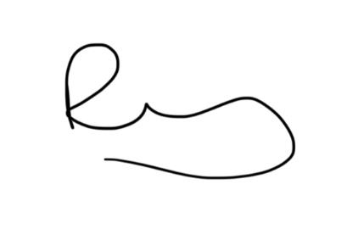
Ricky Wilson
Streetworks Team Leader
Highways and Transport
0300 123 6780

[Ref: HRiT/JW/67782/]

