Job Description

Directorate: | Resources
Service: | Digital
Location: | Hybrid – based at County Hall in Preston with homeworking
Salary range: | £108,696 - £117,998 | Grade: | LCC D2
Reports to: | Executive Director Resources | Staff responsible for: | TBC

Job Purpose
- Provide high-level vision and leadership to set the strategic direction to achieve digital, data and technology transformation across the council and be the lead authority on information and digital technology management including architecture, design programme/project management and service delivery to meet industry best practice.

- Work in a strategic and forward planning manner in collaboration with council Directors and third-party suppliers to understand current and future business need and present digital technology solutions to deliver these.

- Define and lead the delivery of the digital technology and future operating model roadmap for the council and play a key role in the delivery of organisational transformation.

- Provide strong and authentic leadership to colleagues in the Digital function, ensuring colleagues are well led and focussed on the needs of the council.

Leadership Responsibilities and Expectations
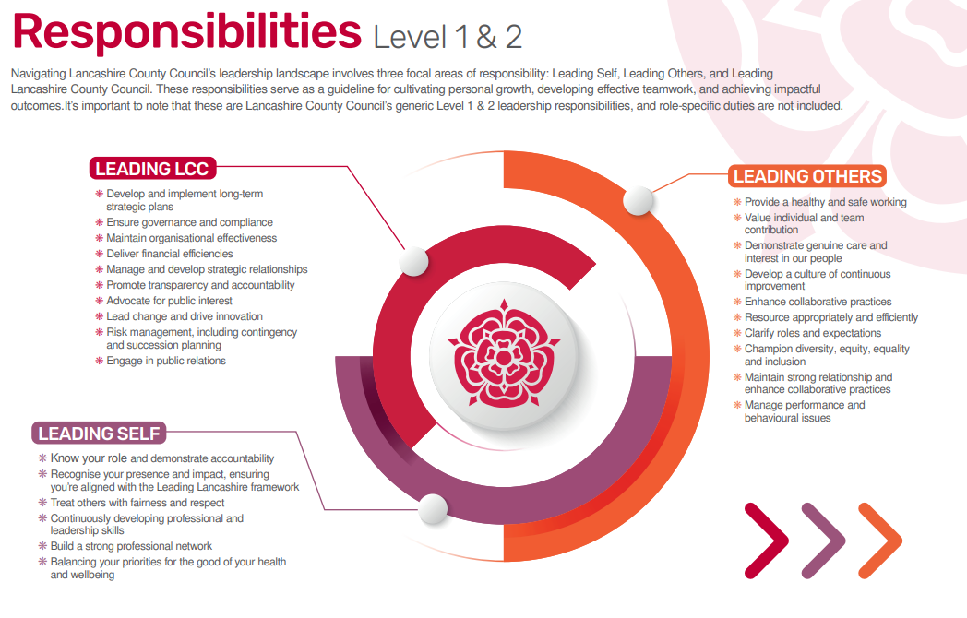

Role-specific accountabilities/responsibilities:
- As a member of the Resources directorate leadership team, support the development and effective implementation of strategy and business plans and ensure the council's core enabling functions are effectively coordinated.

- Develop and lead the implementation of the council's Digital First Strategy to enable and support the delivery of the corporate strategy and ensure effective oversight of the council's Cyber Strategy.

- Lead and develop a high performing Digital function ensuring this delivers high quality, strategic, advisory and transactional services for the council and its partners.

- Support strategic organisation transformation by providing expertise and leadership in the digital element of large-scale change programmes.

- Ensure that the council fulfils its digital regulatory obligations.

- Drive user-centred digital services as a priority across all customer digital touchpoints.

- Implement and lead business enhancing digital technology changes throughout the organisation, developing digital channels and enhanced user experiences.

- Advise the council on information, data and digital matters covering the adoption of best practice Local Government IT and adoption of new emerging technologies, including development of the council's approach to AI.

- Oversee the management and the relationships with third party suppliers, applying the principles of strategic vendor management up to a total value in excess of £40m.

- Provide timely strategic and operational business partnering to the Chief Executive, Executive Management Team, elected members and the wider organisation.

- Develop strong strategic relationships and alliances across the council and its partner network.

- Establish key performance indicators (KPIs) to measure the success of digital initiatives and monitor these metrics to ensure the achievement of goals. This will involve analysing data and using insights to make informed decisions about future strategy.

- Ensure the Councils ICT infrastructure is optimal for a large complex organisation, through the effective strategic planning of replacement systems.

- Be responsible for the Digital function budget and delivery of high quality, value for money services within budgetary parameters.

Other
Equal Opportunities
We are committed to achieving equal opportunities in the way we deliver services to the community and in our employment arrangements. We expect all employees to understand and promote this policy in their work.

Health and safety
All employees have a responsibility for their own health and safety and that of others when carrying out their duties and must help us to apply our general statement of health and safety policy.

Customer Focused
We put our customers' needs and expectations at the heart of all that we do. We expect our employees to have a full understanding of those needs and expectations so that we can provide high quality, appropriate services at all times.

Safeguarding Commitment
We are committed to protecting and promoting the welfare of children, young people and vulnerable adults.

Skills Pledge
We are committed to developing the skills of our workforce. All employees will be supported to work towards a level 2 qualification in literacy and numeracy if they do not have one already.

Our Values
We expect all our employees to demonstrate and promote our values:

Supportive
We are supportive of our customers and colleagues, recognising their contributions and making the best of their strengths to enable our communities to flourish.

Innovative
We deliver the best services we possibly can, always looking for creative ways to do things better, putting the customer at the heart of our thinking, and being ambitious and focused on how we can deliver the best services now and in the future.

Respectful
We treat colleagues, customers and partners with respect, listening to their views, empathising and valuing their diverse needs and perspectives, to be fair, open and honest in all that we do.

Collaborative
We listen to, engage with, learn from and work with colleagues, partners and customers to help achieve the best outcomes for everyone.

Person Specification

All the following requirements are essential unless otherwise indicated by *

Your ability to meet the job requirements will initially be assessed by the information provided on your application but further assessment will be undertaken at interview and, in some cases, by using other types of assessment(s).

Qualifications
- Educated to degree level
- Relevant professional qualification (ITIL Expert or similar)
- Recognised senior management qualification or equivalent
- Evidence of ongoing CPD
Experience
- Substantial experience of working at senior leadership level in digital transformation in a large complex organisation and system level within local government or another public sector employer.
- Successful development of strategic solutions and outcomes to meet statutory requirements, regulations, improved service standards and in response to existing and emerging priorities.
- Experience of developing meaningful external networks (e.g. taking on advisory roles, participating in industry bodies or directorships)
- Working in a challenging financial and/or regulatory environment.
- Project and programme management.
- Delivering cost-improvement programmes and wider corporate change management to support cost and efficiency improvement.
- Proven experience of leading and delivering large-scale change programmes in a complex organisation.
- Evidence of successful monitoring and delivery of end-to-end programmes at scale, through multi-discipline teams.
- Proven experience of working with internal partners to deliver digital focussed business solutions.
- Proven experience of implementing 'customer centred' technology solutions.
- Evidence of efficient management of cloud based (software as a service) contracts.
Essential knowledge, skills & abilities
- Strong, visionary leadership qualities and credibility to inspire trust and confidence in the Digital function and wider organisation.
- Excellent understanding of the political context at a local, regional and national level and the ability to operate sensitively and efficiently within a political environment.
- Strategic and analytical thinking skills to provide creative and fit for purpose solutions to problems within the area of responsibility.
- Ability to work collaboratively, as part of the senior leadership group, and take shared responsibility for organisational performance.
- Internal ambassador who drives a positively engaged and high performing community.
- A sophisticated communicator, able to effectively engage diverse audiences through written and oral communication.
- An understanding of current trends in digital systems leadership.
- Knowledge and experience of successful systems deployment
- Keeps abreast of emerging technological, digital and business trends, develops and executes an IT strategy that takes advantage of these trends, and collaborates with other business leaders to embed digital opportunities in business strategy, taking advantage of emerging technologies to enable the business strategy.

Personal Attributes
The Lancashire Mindset
Demonstrate Growth, Ownership, Optimism, and Positive Impact in all actions and decisions.

Values-Aligned Capabilities and Behaviours
Reflect the Council's core values through supportive, innovative, respectful, and collaborative practices.
Other Essential Requirements
- Commitment to Diversity & inclusion through the ongoing development of an Incisive workplace.
- Commitment to health and safety.
- Display the LCC values and behaviours at all times and actively promote them in others.
- This is an essential car user post
You will be required to provide a car for use in connection with the duties of this post and must be insured for business use. In certain circumstances consideration may be given to applicants who, as a consequence of a disability, are unable to drive.

