Red Rose Letters and Sounds Phonics Catch Up Programme Overview
Red Rose Fast Track Phonics | Red Rose Bounce Back Phonics
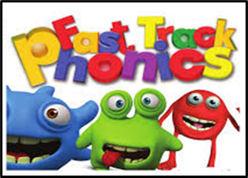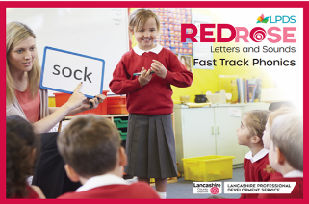  The Primary English and Literacy Team at Lancashire Professional Development Service (LPDS) have developed a brand new systematic, synthetic phonics catch up planning programme supporting Red Rose Letters and Sounds. This planning programme has been developed, evaluated and refined, using the expertise of effective classroom practitioners and phonics experts at LPDS. It is a reworking of the previous Fast Track Phonics document. It includes Red Rose catch up for Phases 2, 3 and 4.  What is included to implement Red Rose Fast Track Phonics?  The programme includes:  • a baseline diagnostic screening for oral blending and segmenting of words.  • an overview of Phase 2, 3 and 4 progression and coverage.  • carefully sequenced 12 weeks planning focusing on Phases 2, 3 and 4, including high frequency words to support fluency.  • comprehensive daily lesson planning following the revisit/review, teach, practise and apply phonic teaching sequence.  • an opportunity to revisit all of Phase 2, 3, and 4 Tricky Words.  • word banks that directly match the teaching of focused graphemes. Plus, additional words to broaden vocabulary and to provide stretch and challenge.  • application opportunities planned throughout to ensure blending and segmenting of words and sentences.  • a detailed games and strategies document.  • a comprehensive assessment tool which includes frequent reflection checkpoints.  Who can use Red Rose Fast Track Phonics?  This planning programme is aimed at supporting children typically in Reception and in Year 1, who need further support in phonics for reading and writing. However, the programme can also be implemented with children in later year groups who are still working on the earlier phases of phonic development. The programme is designed to revisit Phases 2, 3 and 4 in order to embed, accelerate and secure application in reading and writing. | 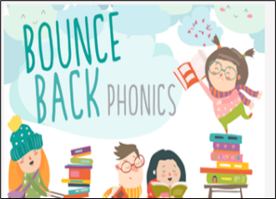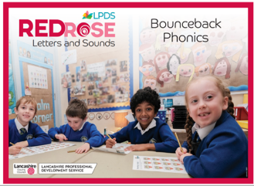  The Primary English and Literacy Team at Lancashire Professional Development Service (LPDS) have developed a brand new systematic, synthetic phonics catch up planning programme following on from Red Rose Letters and Sounds. This planning programme has been developed, evaluated and refined, using the expertise of effective classroom practitioners and phonics experts at LPDS. It is a reworking of the previous Bounce Back Phonics document. It includes Red Rose catch up for Phases 4 and 5.  What is included to implement Red Rose Bounce Back Phonics?  The programme includes:  • a baseline diagnostic screening for blending and segmenting sentences.  • an overview of the Phase 4 and Phase 5 Grapheme Phoneme Correspondences covered.  • carefully sequenced 12 weeks planning focusing on Phase 4 and the high value Grapheme Phoneme Correspondences from Phase 5.  • comprehensive daily lesson planning following the revisit/review, teach, practise and apply phonic teaching sequence.  • an opportunity to revisit all of Phase 2, 3, 4 and 5 Tricky Words, High Frequency Words and Common Exception Words (both decodable  and non-decodable).  • word banks that directly match the teaching of focused graphemes. Plus, additional words to broaden vocabulary and to provide stretch and challenge.  • application opportunities planned throughout to ensure blending and segmenting of words and sentences.  • a detailed games and strategies document.  • a comprehensive assessment tool which includes frequent reflection checkpoints.  Who can use Red Rose Bounce Back Phonics?  This planning programme is aimed at supporting children in Year 2 and KS2, who may have missed or not fully understood some of the crucial GPCs within Phases 4 and 5 of Red Rose Letters and Sounds. Some children may also have difficulty with the application of blending and segmenting words and sentences within these phases.


Red Rose Fast Track Phonics

Red Rose Bounce Back Phonics
https://www.lancashire.gov.uk/lpds/publications/?q=Bounce+Back+

