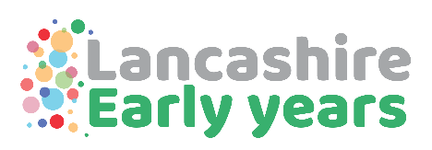

How can the Early Years team provide support to the Inclusion hub leads in order for children to experience a smooth transition into reception classes in September 2024?
- Data will be collected from pre-school providers and will be shared with inclusion hub leads once school places have been confirmed, highlighting any potential difficulties that children may have in settling into their new school.
Data will be requested in April so will be shared with hub leads via Mike Mitchell in May.

- School readiness training for NURSERY classes is available here School readiness and supporting pre-school children for the transition to school - Lancashire County Council

- Are you ready? Training for RECEPTION classes is available here Nursery settings and schools training courses - Lancashire County Council please note this session was offered to all schools last summer

- BEHAVE (Brain, Emotions, Home, Assessment, Values, Environment)
New training for NURSERY AND RECEPTION CLASS PRACTITIONERS
An introduction to the new Early Years BEHAVE Roadmap, Audit Tool and Guidance Materials
Recommended for every EYFS Practitioner
Places available here Behave - Lancashire County Council

- All preschool providers are encouraged to use the uniform transition documents here Pre-school transition documents - Lancashire County Council

- NURSERY AND RECEPTION CLASS PRACTITIONERS are being encouraged to sign up to the last round of Early Years Professional Development Training. This will begin at the end of March 2024. It is a Communication and Language programme predominantly and although aimed at those working with 2-4 year olds, reception class practitioners are being encouraged to join in order to support the closing of any gaps in learning quickly. This is nearly full. Please see Early Years Professional Development Programme – Currently registering interest for April 2024 starts (earlyyearspdp.com) to register the interest of any of your EYFS practitioners

- For consultancy support in your school please see Early years consultancy visits - Lancashire County Council

For information
- All PVI preschool providers are being supported to use the WELLCOMM communication and language tool.

Contact Annette.shepherd@lancashire.gov.uk or earlyyearscentre@lancashire.gov.uk

