SHREC OBSERVATION CHECKLIST

Is the adult at the child’s level?

Is she paying attention to what the children are focused on?


Does the adult follow the child’s lead?
Do they respond to their verbal communication, commenting on what they can see, hear or
Feel?

Does the adult repeat what the child says and build on it by adding more words to turn it into a sentence?
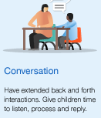
Does the adult have extended back and forth interactions? Does she give the children time?

