Job Description

Directorate: | Resources
Service: | Strategy & Transformation
Location: | Hybrid – based at County Hall in Preston with homeworking
Salary range: | £108,696 - £117,998 | Grade: | LCC Director 2
Reports to: | Executive Director Resources | Staff responsible for: | TBC

Job Purpose
- Provide high-level vision and leadership to drive strategic initiatives aimed at shaping the future direction of the council.

- Lead on initiatives aimed at reforming and optimising public services through innovation, efficiency, and effectiveness, ensuring alignment with the council's corporate strategy, government policies and meeting the evolving needs of our communities.

- Work in a strategic and forward planning manner in collaboration with elected members and senior colleagues to understand current and future challenges for local government and present sound solutions to respond to these.

- Provide strong and authentic leadership to colleagues in the Strategy and Transformation and wider council function, ensuring colleagues are well led and focussed on the needs of the council.

- Embed and further develop the council's strategic plan informed by public and partner engagement, aligned to the resources of the county, and supported by processes that drive service planning and continuous improvement.

- Support the organisational readiness for Local Government Reorganisation (LGR), working across all council departments and linking in with the wider LGR transition programme

- Drive the council's transformation and improvement agenda based on insight, best practice, demand management, customer focussed design and effective programme management.

- Provide leadership on key national agendas including local government reorganisation and wider national reforms

- Lead on the development of key strategic partnerships at council, regional and national level to drive improved outcomes and realisation of council priorities.

- Lead and drive the council's data and insight agenda to enable services to be customer focussed, responsive, efficient, and effective.

- Lead the council's policy and performance function to ensure awareness of the national picture, adoption of continual best practice, and development of a performance framework to ensure delivery.

- Act as lead strategic adviser to the Cabinet, Chief Executive, Management team and wider members to realise their goals.

Leadership Responsibilities and Expectations
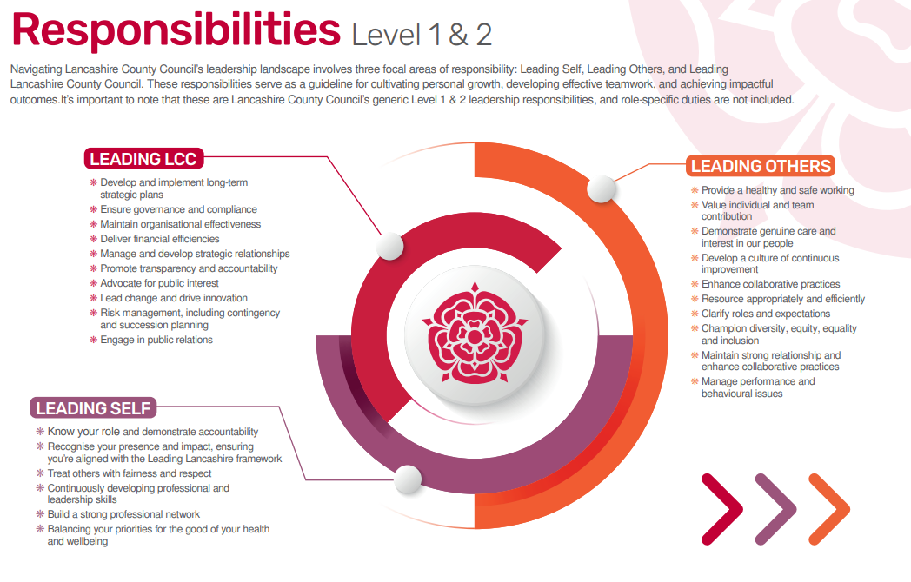

Role-specific accountabilities/responsibilities:
Leadership
- As the key strategic advisor to the Chief Executive and lead Members on strategic direction of the council, having interpreted national and regional policy and identified best practice across the sector.
- As a member of the Resources directorate leadership team, support the development and effective implementation of corporate strategies and business plans and ensure the council's core enabling functions are effectively coordinated.
- Lead, mentor and develop a high performing strategy, transformation and improvement function, fostering a culture of innovation, continuous improvement and accountability and ensuring this delivers high quality, strategic, advisory, and transactional services for the council and its partners.
- Role model behaviours that inspire confidence and set a clear vision for the future.
- Promote collaboration and effective communication within the Strategy and Transformation function and across directorates.
- Provide timely strategic and operational business partnering to the Chief Executive, Executive Management Team, elected members and the wider organisation.
Organisational Transformation
- Provide strategic vision and leadership for strategy, transformation and improvement, aligning initiatives with the overall objectives and ambitions of the council.
- Work closely with senior colleagues and elected members to develop a comprehensive reform agenda that addresses key challenges and opportunities.
- Initiate and drive change that supports the delivery of the council's corporate plan.
- Support strategic organisational transformation by providing expertise and leadership in large-scale change programmes.
Service Delivery Improvement
- Identify opportunities for improving service delivery and customer satisfaction through process optimisation, technology adoption, and service redesign.
- Collaborate with senior colleagues to implement innovative solutions that enhance the quality and accessibility of public services.
Data-Driven Decision Making
- Promote the use of data and analytics to inform decision-making processes and measure the impact of reform initiatives.
- Develop a fresh approach to data and analytics which enables the council to make informed decisions
- Establish key performance indicators (KPIs) to monitor and evaluate the success/impact of reform initiatives.
Community/Stakeholder Engagement
- Develop strong strategic relationships and alliances across the council and its partner network, including local communities and stakeholders, to build strong partnerships and support for reform initiatives.
- Work collaboratively with stakeholders to gather insights, address concerns, and ensure a coordinated approach to reform initiatives.
Policy Development
- Oversee the thorough analysis of existing corporate policies, recommending and implementing changes to enhance efficiency and effectiveness.
- Provide expert guidance on legislative changes and best practice to inform policy development, ensuring compliance and adapting strategies accordingly.

Other
Equal Opportunities
We are committed to achieving equal opportunities in the way we deliver services to the community and in our employment arrangements. We expect all employees to understand and promote this policy in their work.

Health and safety
All employees have a responsibility for their own health and safety and that of others when carrying out their duties and must help us to apply our general statement of health and safety policy.

Customer Focused
We put our customers' needs and expectations at the heart of all that we do. We expect our employees to have a full understanding of those needs and expectations so that we can provide high quality, appropriate services at all times.

Safeguarding Commitment
We are committed to protecting and promoting the welfare of children, young people and vulnerable adults.

Skills Pledge
We are committed to developing the skills of our workforce. All employees will be supported to work towards a level 2 qualification in literacy and numeracy if they do not have one already.

Our Values
We expect all our employees to demonstrate and promote our values:

Supportive
We are supportive of our customers and colleagues, recognising their contributions and making the best of their strengths to enable our communities to flourish.

Innovative
We deliver the best services we possibly can, always looking for creative ways to do things better, putting the customer at the heart of our thinking, and being ambitious and focused on how we can deliver the best services now and in the future.

Respectful
We treat colleagues, customers and partners with respect, listening to their views, empathising and valuing their diverse needs and perspectives, to be fair, open and honest in all that we do.

Collaborative
We listen to, engage with, learn from and work with colleagues, partners and customers to help achieve the best outcomes for everyone.

Person Specification

All the following requirements are essential unless otherwise indicated by *

Your ability to meet the job requirements will initially be assessed by the information provided on your application but further assessment will be undertaken at interview and, in some cases, by using other types of assessment(s).

Qualifications
- Educated to degree level.
- Relevant professional qualification (e.g., public administration, business administration or similar)
- Recognised senior management qualification or equivalent.
- Evidence of ongoing CPD.
Experience
- Substantial experience of working at a senior level in leading and implementing strategic and innovative public sector reform programmes within local government or another public sector employer.
- Proven record of driving through successful reform initiatives, with the ability to drive cultural and operational change within a large complex organisation.
- Successful development of strategic solutions and outcomes to meet statutory requirements, regulations, improved service standards and in response to existing and emerging priorities.
- Experience of developing meaningful external networks
- Project, programme and portfolio management.
- Proven experience of leading and delivering large-scale change programmes in a complex organisation to support cost and efficiency improvement.
- Evidence of successful monitoring and delivery of end-to-end programmes at scale, through multi-discipline teams.
Essential knowledge, skills & abilities
- Strong, visionary leadership qualities and credibility to inspire trust and confidence in the Strategy and Transformation function and wider organisation.
- Ability to deliver at pace and be seen as innovative, dynamic, proactive, and forward-looking.
- Extensive knowledge of local government and other organisational best practice to help shape Lancashire.
- Knowledge of public sector policies, regulations, and governance structures in the UK.

- Excellent understanding of the political context at a local, regional, and national level and the ability to operate sensitively and efficiently within a political environment.
- Strategic and analytical thinking skills to provide creative and fit for purpose solutions to problems within the area of responsibility.
- Ability to work collaboratively, as part of the senior leadership group, and take shared responsibility for organisational performance.
- Internal ambassador who drives a positively engaged and high performing community.
- A sophisticated communicator, able to effectively engage diverse audiences through written and oral communication.
Personal Attributes
The Lancashire Mindset
Demonstrate Growth, Ownership, Optimism, and Positive Impact in all actions and decisions.

Values-Aligned Capabilities and Behaviours
Reflect the Council's core values through supportive, innovative, respectful, and collaborative practices.
Other Essential Requirements
- Commitment to Diversity & inclusion through the ongoing development of an Incisive workplace.
- Commitment to health and safety.
- Display the LCC values and behaviours at all times and actively promote them in others.
- This is an essential car user post
You will be required to provide a car for use in connection with the duties of this post and must be insured for business use. In certain circumstances consideration may be given to applicants who, as a consequence of a disability, are unable to drive.

