Job Description

Directorate: | Adult Social Care
Service: | Adults Service
Location: | County Wide
Salary range: | £46,142 - 51,356 per annum (pay award pending) | Grade: | 10
Reports to: | Service Manager | Staff responsible for: | Yes

Job purpose and scope
The Team Manager is responsible for leading and managing a team within Adult Social Care to deliver high-quality, lawful and person-centred services.
The postholder will provide strong professional leadership, ensuring robust decision-making and positive outcomes for people who draw on support. The role focuses on maintaining high standards of professional practice, performance and continuous improvement, supported through supervision, coaching and a strong learning culture.
The postholder will operate with a high degree of autonomy and work collaboratively with internal and external partners.
The postholder will be required to be flexible and adaptable to support across any team within Adults, Health and Wellbeing to respond to emerging service demands.

Performance Indicators
- Quality of advice/service against legal, safety and best practice standards
- Understanding and achieving service and directorate level targets and objectives
- Adherence to internal/external quality standards if applicable
- Ensuring service delivery is in line with policies and procedures
- Accuracy and timeliness of information recording and processing
- Customer and stakeholder feedback is collated and used
- Leading Lancashire Framework

Leading Lancashire – Our Leadership Framework
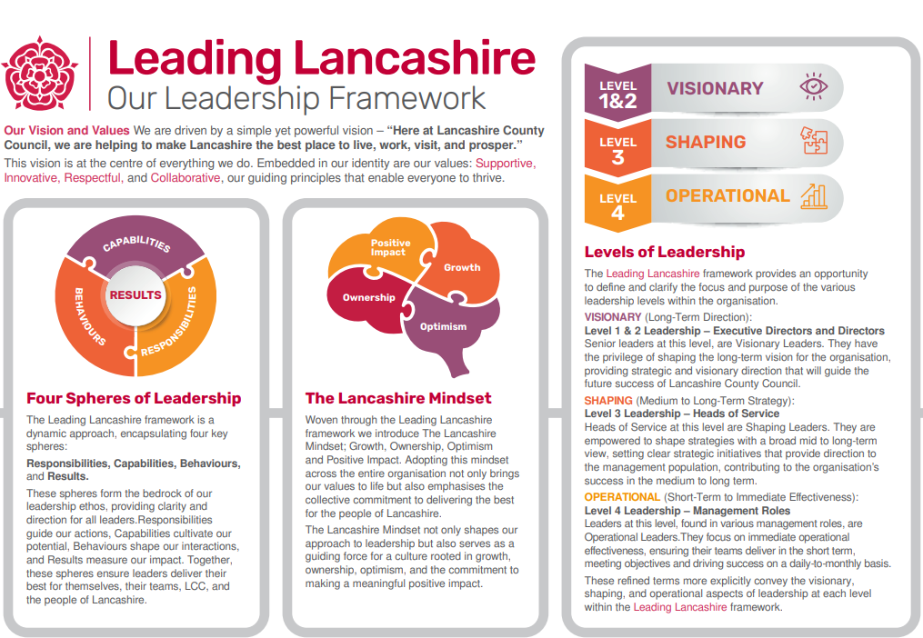

Accountabilities/Responsibilities
- Oversee the delivery of person-centred, strengths-based support in accordance with legislation, policy and best practice
- Ensure all practice is safe, lawful and aligned with statutory responsibilities, including safeguarding duties
- Provide expert professional advice, guidance and oversight to registered professionals, practitioners and support staff
- Maintain robust oversight of safeguarding activity, risk management and case progression, ensuring team members have safe and manageable workloads
- Promote high-quality decision-making and foster a positive, inclusive and high-performing team culture
- Provide effective line management to professional and support staff within the team
- Deliver high-quality supervision, appraisal and performance management to drive continuous improvement
- Coach, mentor and support staff development, including newly qualified or newly registered staff and students, using reflective discussion to promote effective practice and sound risk management
- Identify learning opportunities and embed continuous professional development
- Ensure staff maintain professional standards, including Social Work England or the Health and Care Professions Council registration requirements, where applicable
- Manage workflow and allocation to ensure timely and effective service delivery
- Ensure accurate and timely recording and effective use of information systems
- Use data and performance insights to inform decision-making, resource deployment and service improvement
- Provide insight into service performance, risks and local intelligence
- Work collaboratively with internal teams and partner agencies to deliver integrated, person-centred outcomes
- Maintain and strengthen multi-agency relationships to ensure coordinated, high-quality responses and ongoing oversight of service standards
- Support flexible deployment of staff to respond to emerging priorities
- Manage HR matters including absence, conduct and performance in line with policy
- Carry out all duties in accordance with the Council’s policies, procedures and standards of conduct

Other
- Equal Opportunities
We are committed to achieving equal opportunities in the way we deliver services to the community and in our employment arrangements. We expect all employees to understand and promote this policy in their work.

- Health and safety
All employees have a responsibility for their own health and safety and that of others when carrying out their duties and must help us to apply our general statement of health and safety policy.

- Customer Focused
We put our customers' needs and expectations at the heart of all that we do. We expect our employees to have a full understanding of those needs and expectations so that we can provide high quality, appropriate services at all times.

- Safeguarding Commitment
We are committed to protecting and promoting the welfare of children, young people and vulnerable adults.

- Skills Pledge
We are committed to developing the skills of our workforce. All employees will be supported to work towards a level 2 qualification in literacy and numeracy if they do not have one already.

Our Values
We expect all our employees to demonstrate and promote our values:

- Supportive
We are supportive of our customers and colleagues, recognising their contributions and making the best of their strengths to enable our communities to flourish.

- Innovative
We deliver the best services we possibly can, always looking for creative ways to do things better, putting the customer at the heart of our thinking, and being ambitious and focused on how we can deliver the best services now and in the future.

- Respectful
We treat colleagues, customers and partners with respect, listening to their views, empathising and valuing their diverse needs and perspectives, to be fair, open and honest in all that we do.

- Collaborative
We listen to, engage with, learn from and work with colleagues, partners and customers to help achieve the best outcomes for everyone.

Person Specification

All the following requirements are essential unless otherwise indicated by *

Your ability to meet the job requirements will initially be assessed by the information provided on your application but further assessment will be undertaken at interview and, in some cases, by using other types of assessment(s).

Qualifications
- Professional qualification in Social Work or Occupational Therapy recognised in the UK.
- Current registration with Social Work England or the Health and Care Professions Council, as appropriate.
- Management qualification or evidence of formal management training*.
- Evidence of post-qualification training and continuous professional development.
Experience
- Substantial post-qualifying experience as either a Qualified Social Worker or a Qualified Occupational Therapist
- Experience of setting priorities and managing competing workload demands.
- Experience of leading, managing and supporting professional staff*
- Experience of safeguarding practice and/or complex risk management*.
- Experience of providing advice and guidance in relation to decision-making and practice, ensuring professional standards are maintained.
- Experience of effective demand, workflow and resource management*.
- Experience of identifying, assessing and responding to emerging or immediate risks and issues.
- Experience of audit, quality assurance or practice review activity*.
Essential knowledge, skills & abilities
- Thorough understanding of relevant legislation, policy and practice standards within Adult Social Care.

- Experience of working effectively with partner agencies and multidisciplinary professionals.

- Excellent understanding of relevant legislation and its application, with the ability to work within a clear legal and professional accountability framework.

- Ability to oversee and improve quality standards of practice and address professional conduct issues.

- Strong IT skills, particularly in Microsoft Office, Microsoft Teams and relevant case management systems.

- Data interpretation and analysis skills, including demand management, trend analysis, resource planning and workload oversight to improve service effectiveness.

- Ability to motivate and support colleagues, developing an open and transparent team culture.

- Ability to organise, prioritise and respond to conflicting service demands and responsibilities in a fast-changing environment.

- Conflict resolution skills, with the ability to respond effectively to pressured or sensitive issues while balancing operational and people needs.

- Ability to respond quickly, assess information and understand the impact of decisions within a busy working environment.

- Effective written and verbal communication skills appropriate to a range of audiences and situations.

- Commitment to supporting and improving practice standards and professional capability through continuous professional development, supervision and appraisal.

- Ability to maintain confidentiality and handle sensitive information appropriately.

- Ability to think creatively and lead solutions to complex problems.
Other essential requirements
- Commitment to equality and diversity.
- Commitment to health and safety.
- Display the LCC values and behaviours at all times and actively promote them in others.
- This is an essential car user post
You will be required to provide a car for use in connection with the duties of this post and must be insured for business use. In certain circumstances consideration may be given to applicants who, as a consequence of a disability, are unable to drive

